(An organization for people’s awareness in Uttarakhand Himalayas)

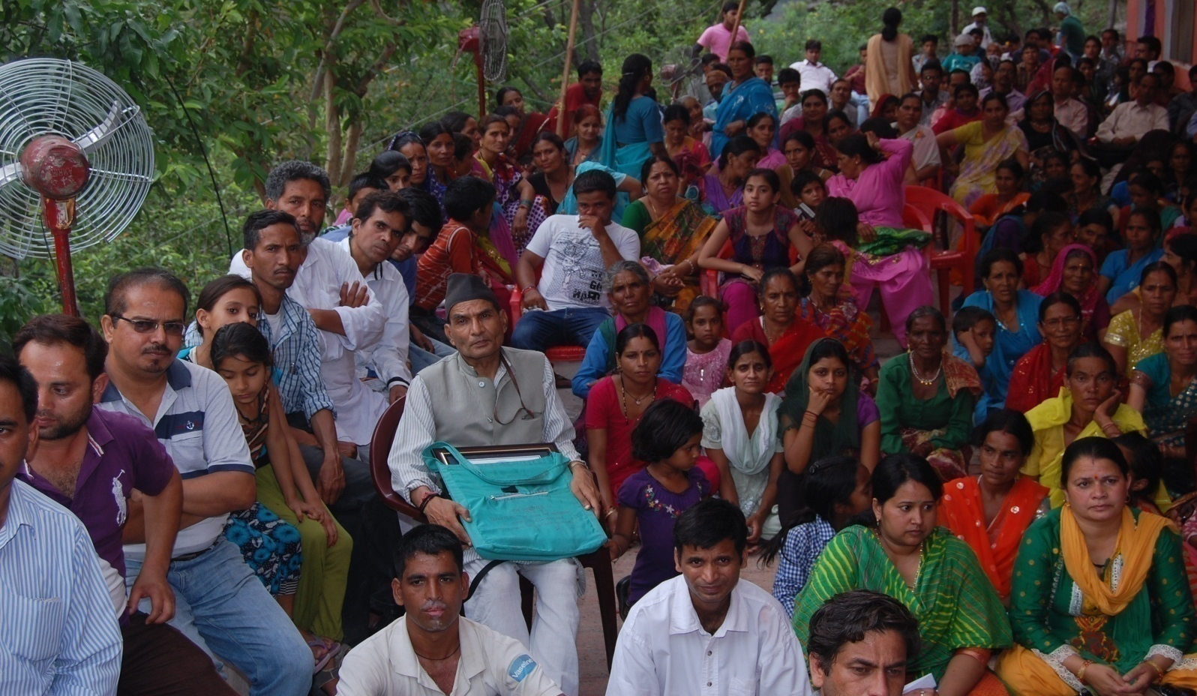
An activity Report 2015

Uttarakhand Jan Jagriti Sansthan
Jagriti Bhawan
Village Khadi, P.O. Jajal
Dist. Tehri Garhwal
Contact No. 01378-230252, Mob. 9412964003 (Aranya Ranjan)
E mail: ujjs_jagritisansthan@hotmail.com, aranya.ranjan@gmail.com

The Uttarakhand Jan Jagriti Sansthan Action, Resource and Advisory Team
- Alok Prabhakar  - Vichitr Singh Routela  - Vikram Singh Panwar  - Prof. Virendar Painyuli  - Dhoom Singh Negi  - Manoj Pande  - Dulari Devi  - Sheela Raturi  - Parwati Khati  - Kumla Devi  - Godambari Devi  - Roshni Devi  - Baddei Devi  - Bachani Devi  - Sarla Routela  - Kusuma Ghildiyal  - Bindu Devi  - Archna Nautiyal  - Aranya Ranjan  - Phool Das Daundiya  - Dhoom Singh Mandrwal | - Vikas Kukreti  - Sunita Bahuguna  - Kushla Negi  - Mamta Mandrwal  - Durga Prasad Kanswal  - Suresh Bhai  - Kavita Panwar  - Sameera Rawat  - Srijana Rana  - Champal Rana  - Ranbeer Routela  - Sanjay Kothiyal  - Rajiv Nayan Bahuguna  - Suvidha Devi  - Kiran Rawat  - Anita Bhandari  - Rakesh Bahguna  - Om Prakash Bahuguna  - Sumit Panwar  - Bishan Singh Mandrwal  - Makani Dev

Uttarakhand Jan Jagriti Sansthan Partner and Support Organizations
- Uttarakhand Mahila Jagriti Parishad  - Mahila Samkhya  - Himalaya Seva Sangh  - Mountain Forum Himalayas  - Himcon  - CASA  - Mountain Collective  - Action Aid  - Women Power Connect  - Sajha Manch  - Child Rights and You | - Legal Literacy and aid cell  - DMMC  - VANI  - National Human Rights Defenders  - Uttarakhand State Children Welfare council  - Right To Education Forum  - District PC PNDT committee  - Pragya Arts  - Henvalvani Community Radio

The Uttarakhand Jan Jagriti Sansthan:
The history of Uttarakhand Jan Jagriti Sansthan (UJJS) goes back to the well known Chipko Movement (Hugging the Trees Campaign). UJJS founding Chairperson Late Shri Pratap Shikhar along with other co-activists was actively involved in a campaign to protect the forests from massive tree felling that was going on in the Himalayan region during the early 1970s.
Having gone through this experience the founding members felt the need of taking up an integrated development program in uttarakhand Himalayas while focusing in the Henval river catchment villages to start with. In order to provide a platform for ensuring an all round development of the people of this region a few of them decided to build up a community organization and with this the foundation of “Uttarakhand Jan Jagriti Sansthan” was laid in the year 1983 as a voluntary organization at a Place Called Khadi which is situated close to the river Henval and is popularly known as Jagriti Bhawan among the local communities.
Uttarakhand Jan Jagriti Sansthan has been focusing on action programs and activities that would help in women empowerment, natural resource management, water conservation & restoration, safe and clean environment, strengthening of local self governance, disaster management & its mitigation, preparing the mountain communities for mitigating effects of climate change and ensuring rights of unprivileged and displaced people. Uttarakhand Jan Jagriti Sansthan works with the strategy of mass mobilization along with creative development of the Communities.
UJJS has taken up several projects and programs introducing new innovations to help and assist the mountain communities have a better and ecologically sustainable life. Construction of improved smokeless wood stoves, low cost toilets, roof water harvesting tanks, compost pits, making bio-mass briquettes and biogas, construction of small ponds known as chahal in local parlance for water harvesting and using them as multipurpose percolation tanks for ground water recharge, Construction of earthquake resistant houses, Introducing eco-san toilets, revival and rejuvenation of springs sheds to improve the quantity and quality of water while bringing in energy efficient, sustainable and low cost water filtration techniques through various experts and partner organizations.
Plantation drives have consistently been taken up to revive and rejuvenate the forest cover in the Henval river catchment villages. Several community based plant nurseries have been raised to develop and propagate tree saplings that would provide food, fodder, fruit and fuel needs of the mountain communities. Emphasis is laid and communities are being organized to protect the existing forest cover through controlled use of community forest lands and pastures for which social and bio fencing methods are being adopted and also stone wall fencing has been taken up with community participation.
UJJS team has worked together with village communities of Tehri Garhwal building up several strong women groups, youth groups and teams of enthusiastic and vibrant children always ready to take part in all the constructive campaigns and actions that were taken up to usher in a change. Some of the important and successful campaigns that need a special mention are : mobilizing the Tehri administration for providing potable drinking water to the village communities of Than, Bidon, Khankar, Sunarkot and Tipali that were facing acute water problems forcing women to walk several kilometers for bringing potable water, UJJS activists initiated awareness drives against several superstitions and evil practices prevalent in the communities and has been successful to a large extent in removing them. One important success story is that of stopping the practice of sacrificing animals using religion as an excuse.
UJJS took up series of programs and activities to undertake strengthening of women groups and local self governance through capacity building, training programs, and exposure and exchange programs for women, youth, children and Panchayati Raj Institutions for skill and leadership development. Campaign and protest actions against alcoholism, women and child abuse have been constantly taken up by UJJS activists there by providing strength solidarity and support to the suffering communities.
An important aspect of UJJS activities was to initiate basic education drives by opening kinder gardens in the remote far flung villages of its program area there by giving the much needed relief to the women and other family members who were often forced to leave their little children alone and uncared at home while they went out to attend to the day to day fodder, fuel, water and agricultural needs of the family.
Absence of any proper health care facilities made UJJS activists to take up series of health care programs bringing in some relief to the local communities. Projects and programs where specially taken up to cater to the needs of women and adolescent girls in particular. Several young girls were sent to get trained as professional health workers at different training institutions and hospitals so that they could come back and serve the mountain communities.
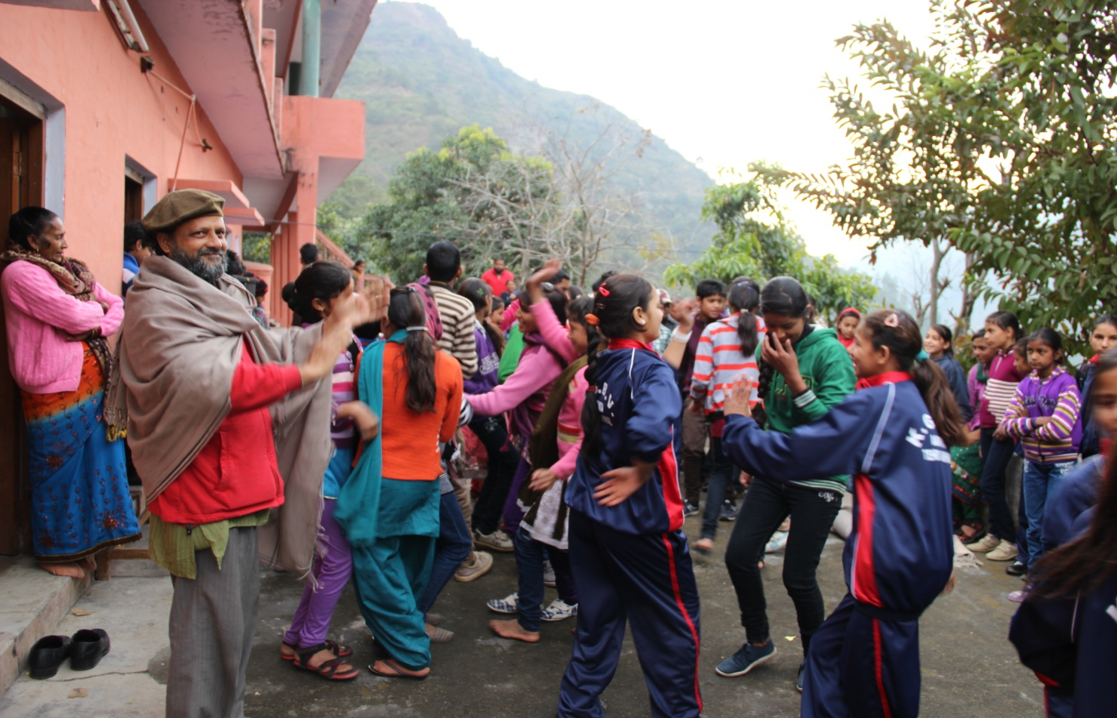
In the last three decades Uttarakhand Jan Jagriti Sansthan activists along with several other community organizations have succeeded in bringing visible impacts in the areas of environment and ecological restoration, women and child empowerment, preparedness of communities for local self governance and awareness status of health and sanitation. UJJS feels that a lot needs to be done in the present complex socio-economic scenario for preparing the communities for an environmentally sound and ecologically sustainable life style and is making continuous effort in this direction. UJJS is looking forward for creative ideas, inputs, solidarity and support to strengthen its initiatives in the Himalayan region.
UJJS has been working to focus on child right issues:
UJJS has been working through a network of likeminded voluntary organizations, INGOs and Government institutions while taking up practical action programs along with village communities of Uttarakhand Himalayas.
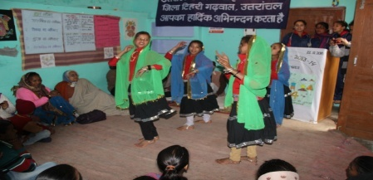
School Children and youth groups are being consciously and creatively engaged through a series of residential and village level workshops and work camps to sensitize and involve them in environment and ecological restoration tasks. Different cultural activities group dance, drama, sports and games along with other creative inputs were given to the smaller children groups bringing in new enthusiasm among them. A residential workshop to initiate a “Dialogue among Children” calling it “Bal Samvad” in being organized every year to develop a new line of creative leadership in the region. This effort has helped in preparing new and fresh volunteers to take the UJJS missions forward.
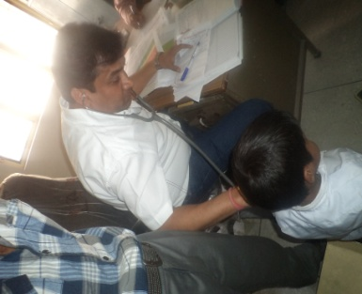
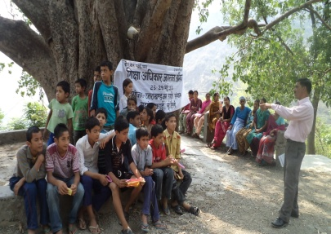
A detailed study was organized to access the real condition of children and their environment through a pilot study conducted in the 15 villages of the Henval river watershed covering around 750 households with population of 4000 people. This action research continued for 3 years giving UJJS activist insights on the poor and almost pathetic conditions of health, nutrition, education, girl child issues and prevalence of child labors. Having identified issues and case studies with clear data, UJJS shared and interacted with different line departments of the local government who are actually responsible to deal and resolve the problems that emerged out of this study.
This study was extended focusing on the health status of children and a total of 45 villages were covered in the 3 administrative blocks of Narender Nagar, Chamba and Jaunpur in Tehri Garhwal district. UJJS identified that 35% children were suffering from malnutrition of which 13% were of serious nature and needed special attention and care. UJJS initiated a process of team work along with ICDS (integrated Child Development Scheme), PHC (Primary Health Center) and Base Hospital at Narender Nagar to help these families for treating the children. Efforts have also been made to link up the families of all these villages with all the focused development schemes of state and central government on child welfare.
Organizing women groups:
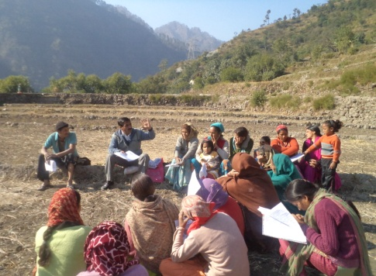
Women Groups have been organized for taking up various social action campaigns and activities at the community level. In the last 3 decades of UJJS interventions forming and activating women groups has been an important aspect its strategy. Having engaged with more than 100 village level active women groups UJJS is intensely working with 25 women groups and have helped in the formation of around 150 women mutual support groups providing them social and economic security and independence. This has helped in bringing out empowered women entrepreneurs in agro horticulture ventures.
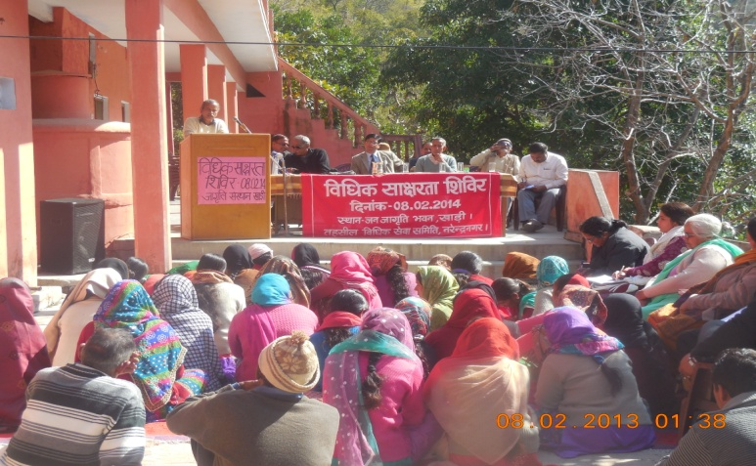
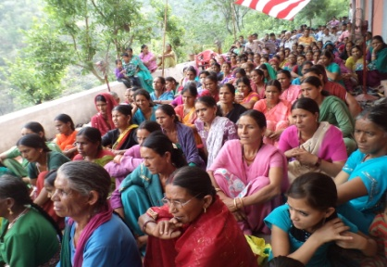
A federation of these women groups called “Uttarakhand Mahila Jagriti Parishad” (Uttarakhand Women Awareness Forum) has been formed from among the villages in the catchment area of Henval Valley. UJJS feels that women are the back bone of the mountain communities and efforts should be made to organize and strengthen them in order to resolve the complex problems and issues faced by them and appeals to all the concerned people to join hands in this venture.
UJJS has taken special and focused initiatives to help and support women in distress facing violence at home and community setups. Efforts have been made to work closely with networks like “Legal Aid Cell”, Women Power Connect, Sajha Manch, Uttarakhand Network for violence against women and Mahila Samkhya to practically help women in need of help.
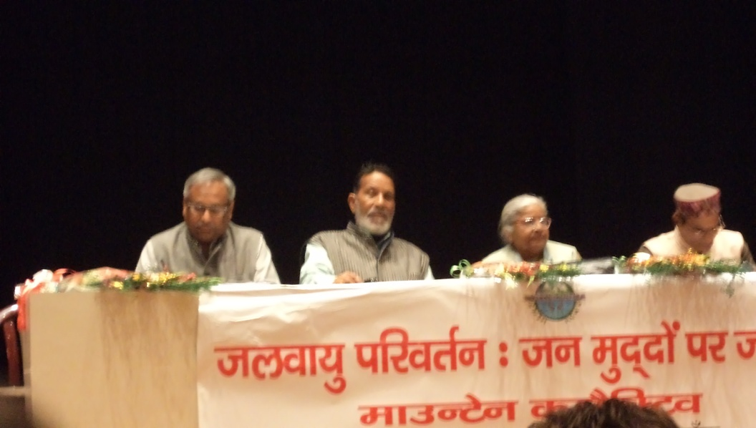
Working on challenges emerging out of climate change issues:
UJJS activists are conscious of the fact that the threats of climate change is adversely effecting the small farmers who are big in numbers and cultivate substantial portion of agricultural land, mostly in rain fed areas and constitutes majority of the poor and marginalized farmers and peasants in the Himalayan Region as well. Their food, nutritional and livelihoods security are at risk in the context of climate change as well as in the present context of developments in agriculture (research and extension) and market.
UJJS became an important partner and initiator of “Mountain Collective” to sensitize the mountain communities on issues and impacts emerging out of climate change at a global level. Several collective campaigns, workshops, meetings, seminars, marches, dialogues, were organized while using different art forms like street theater, folk songs, posters, pamphlets, booklets etc. were brought out focusing on issues concerning climate change.
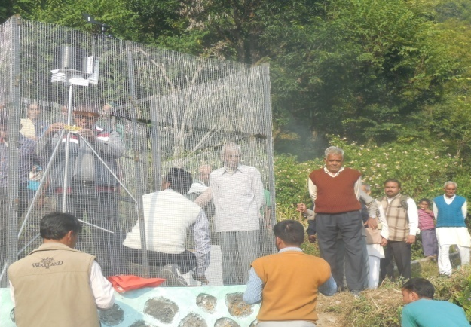
UJJS team has actively participated and represented in various regional, national and international forums and meetings on climate change and has brought in learning and lessons for its community groups to make necessary adaptations and interventions at the ground level.
A field level action research climate monitoring automatic substation has been setup in one of the communities of village “Tipali” of Narender Nagar block. With this a “Climate Change Farmer’s School” locally known as “Jalvayu Parivartan Kisan Pathshala” has been established at “Tipali” where experts from different fields are being invited to interact with the farming community.
UJJS efforts for Disaster relief, reconstruction and mitigation:
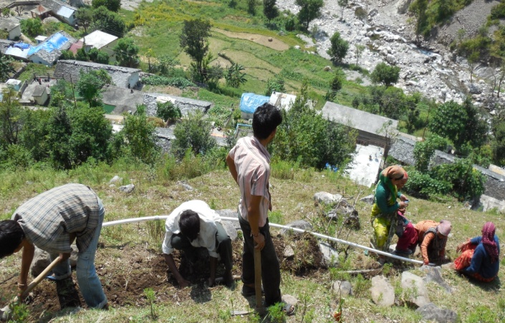
Communities living in the Uttarakhand Himalayas have been facing hardships caused by several natural calamities and disasters caused both by nature and human interferences. UJJS has constantly geared itself to come forward and help the affected communities in the disaster hit areas. UJJS had worked for immediate and long term relief and reconstruction work after the 1991 Uttarakashi earthquake and has since then participated actively in relief work whenever there is a need as result of earthquake, flash floods, fire and forest fire, accidents etc.
In the recent past UJJS team actively got involved to help the victims of flash floods in the years 2012, 2013, 2014 and 2015 that have badly affected the mountain communities of Uttarakhand and Kashmir regions.
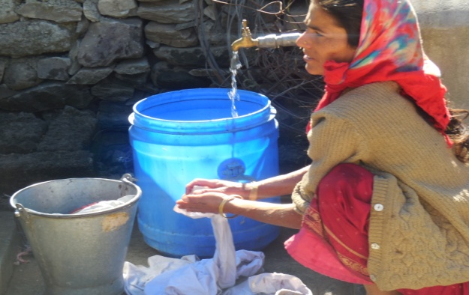
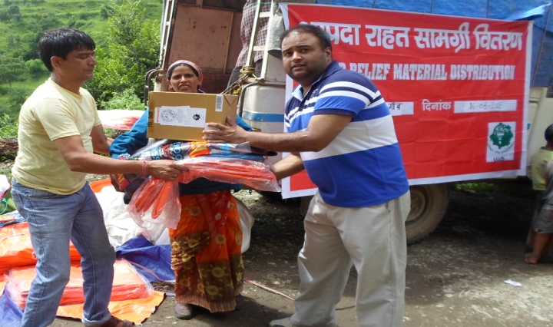
UJJS worked intensively in the 15 villages of Jaunpur block in the Tehri Garhwal district that were badly affected by the flash flood causing massive landslides, destroying houses, farm lands and livestock in the region. Water supplies were severely affected in this area and UJJS took up the reconstruction of water supply channels on a war footing providing relief to more than 1000 families. Immediate relief material was distributed among 110 badly affected families and supported around 1000 children and schools with necessary requirements to start things again.
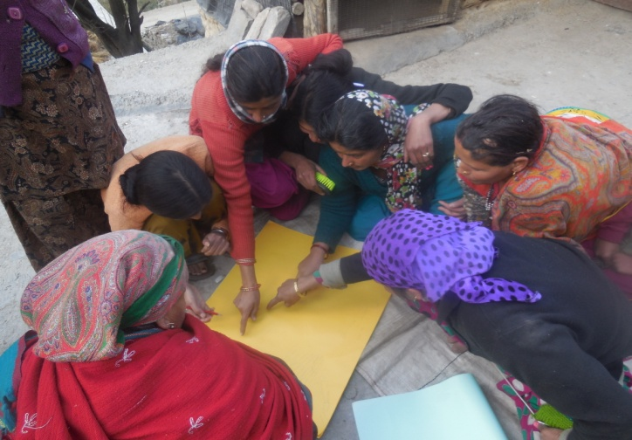
This being a remote area UJJS took up the role of advocacy for the disaster affected communities through media, public hearing, and networking with local and state administration while bringing in several national and international organizations providing expertise and relief to the villagers. Efforts were made to organize the women and children groups providing them resource materials while taking up post traumatic stress relief interactions through workshops and meetings.
The 5 villages that were worst affected were organized for making a long term evacuation and contingency plan after intense discussion and community participation. A 10 days search & rescue training program along with a masons training was organized with support state level Disaster Management and Mitigation Center.
UJJS action program for Land, Water and forest issues:
Protection and conservation of land water and forests have been the core area of UJJS actions and campaigns since its origin. Organizing women and youth groups for developing plant nurseries and tree plantation is an important activity that is taken up on regular basis.
Water harvesting methods like construction of small ponds “chahals”, rain water harvesting tanks, and spring shed rejuvenation activities have also been taken up regularly through various programs and projects.
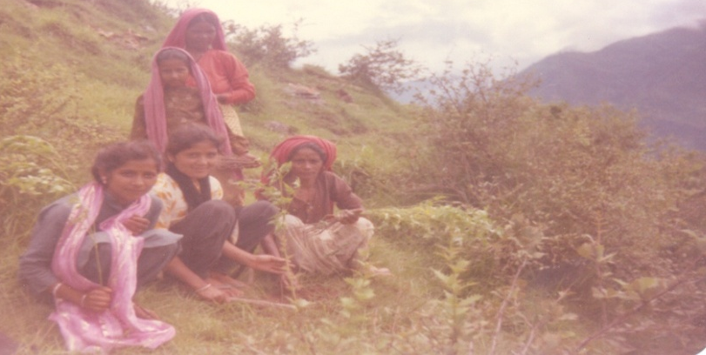
Efforts have been made to mobilize the village communities in the UJJS intervention area for taking up sustainable and organic farming practices while reviving traditional practices of seeds saving and propagation. Ongoing campaign runs to save preserve and propagate broad leaf species trees, bushes, shrubs and grasses in the program villages while planting food, fodder, fuel and fruit bearing tree saplings.
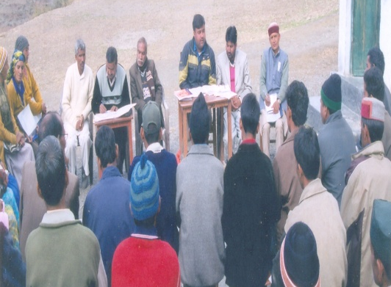
Working for strengthening of local self governance:
Strengthening participatory democracy at local self governance level with an inclusive approach to ensure equitable participation and involvement of women, dalit and marginalized groups in UJJS program area has been taken up in a systematic way. Series of training programs, workshops, seminars, campaigns, development of IEC (information education communication) materials have been made.
UJJS initiatives on cultural activism:
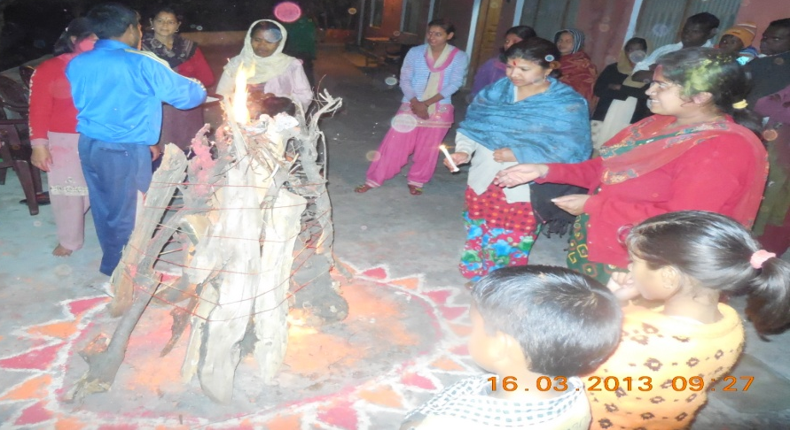
UJJS has always made an effort to convert the struggles of mountain communities into peaceful celebrations through creative and constructive ways in artistic and colorful manners. Folk songs, poetry, stories, theater, dance forms have been collectively organized with communitie’s participation to send the messages of change and revival in the society. Communities look forward to the events that UJJS organizes at Jagriti Bhawan and also at the village level bringing in happy moods and life, thereby breaking the monotony and hardships of day to day life. The get together of poets and folk artists during Holi Milan is a favorite event that people look forward to.
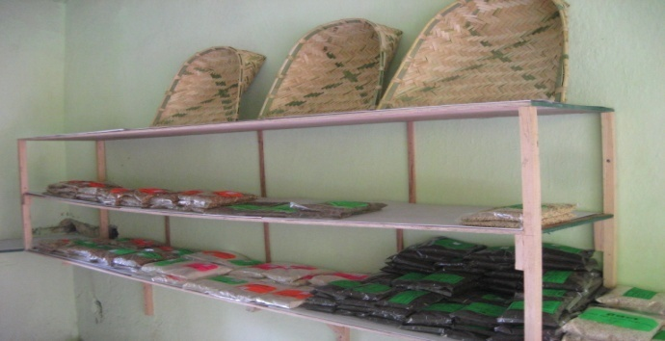
Reviving and strengthening the mountain cultural and traditions:
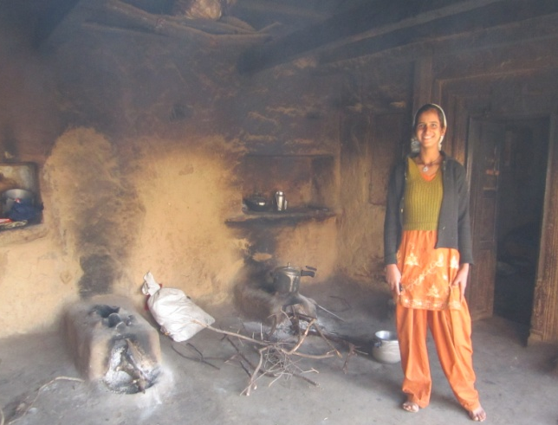
UJJS activists have been making consistent efforts to revive and strengthen valuable community traditions that are being threatened in the present day consumerist market economy. It is being strongly felt during the various discussions that take place at community setups that we need to go back a few steps to rediscover our traditional life styles, cultural practices along with day to day food, clothing and shelter requirements of the diverse Himalayan communities.
A section of the younger generation has already started feeling that there is a disconnect with a clear gap emerging in relation to our traditions and cultural. The food that we consume, the clothing that we use and houses that we construct have become products produced sponsored and advertized by the market driven economy.
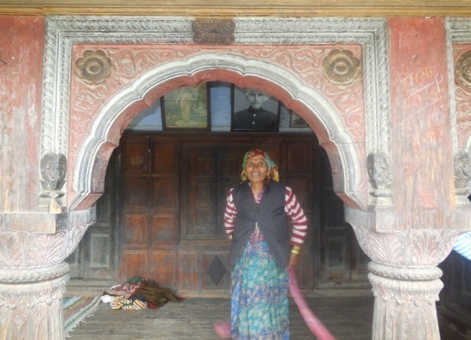
UJJS activists along with the women groups and village communities have made efforts in small ways to initiate dialogues, discussions and practical action programs and projects to revive the missing links. Women groups, farmers and peasants have been encouraged to grow collect and share traditional organic foods that are healthy and promote a sustainable livelihood to mountain communities.
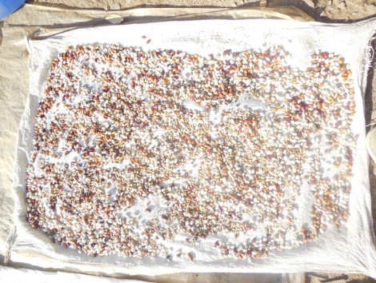
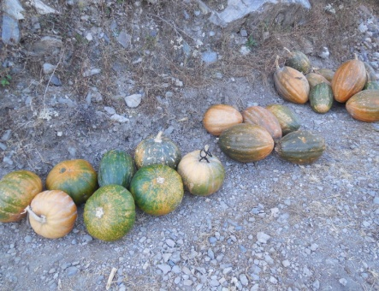
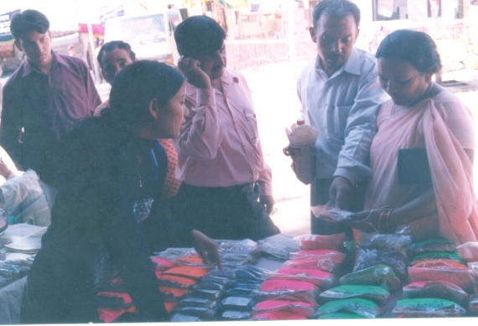
Efforts have been made to open outlets where these seeds of life can be brought after being grown or collected to be shared with people, groups and communities interested in the revival of Himalayan traditions. There is a dream to build up linkages and networks with people and communities engaging themselves in similar journey at a global level.
Uttarakhand Jan Jagriti Sansthan appeals to all the likeminded friends and co-workers working in different areas and missions to help us by sharing ideas, experiences and best practices that one might have come across in different ventures. We look forward for your solidarity and support to strengthen our efforts in this direction.
With love and peace from all the UJJS Team.
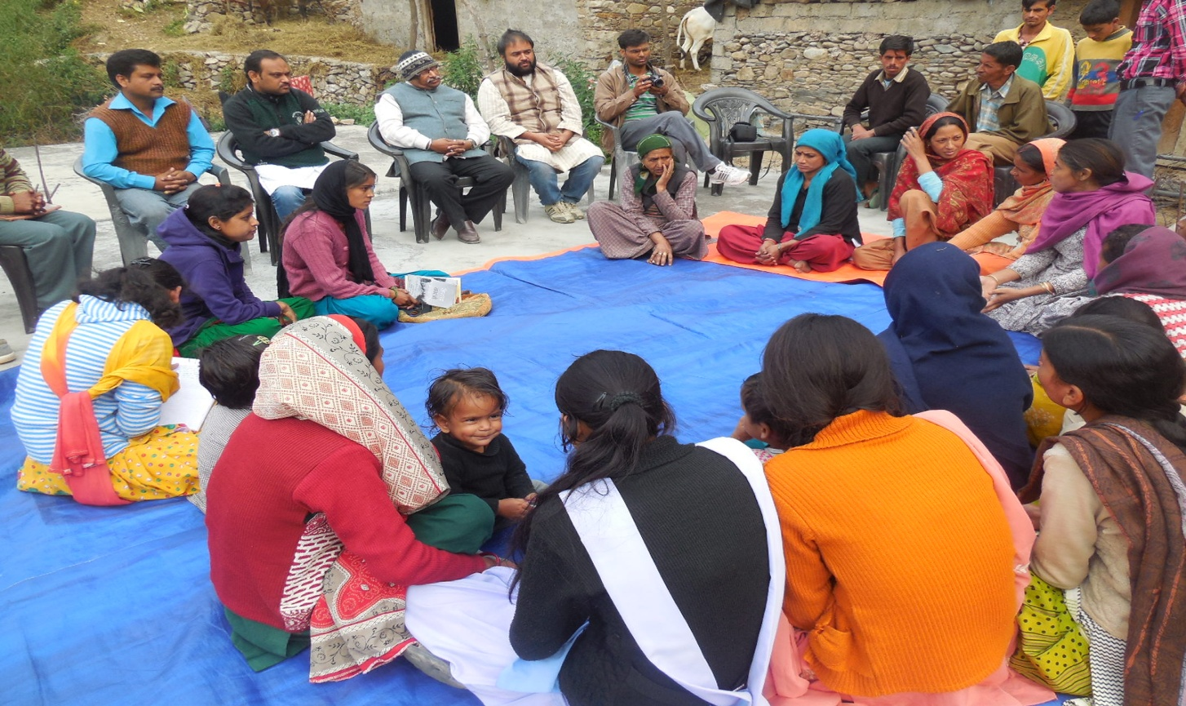
UTTARAKHAND JAN JAGRITI SANSTHAN
A PROFILE
Established on - 20th March 1983
Registered on - 17th September 1983
Legal Status - Registered under the Societies
Registration Act- 1860
Registration No. - 966 (83-84)
FCRA No. - 347960029 dated 05.03.2003
Address - “Jagriti Bhawan”
Khadi, P.O. Jajal
Tehri Garhwal, Uttarakhand
Telephone - 01378-230252,
Cell - +91 9412964003
E-mail - ujjs_ jagritisansthan@hotmail.com
Chief Functionary - Aranya Ranjan
President
Local Bank A/c - State Bank of India
Fakot, Tehri Garhwal
A/C No. 11759934163
IFSC- SBIN0005448
FCRA A/C - State Bank of India
Chamba, Tehri Garhwal
A/C No. 11257306740
. IFSC- SBIN0006534

