In the adobe of the Great Himalayas.
An account of the Mobile Workshop-

The ability to see, hear and speak is useless in the absence of adequate water. Water is the basis of life. Most life forms are born in water and live in it. O water stream, come near me. You are the elixir of immortality.
Atharvaved, 3:13:6

Water is life. Living in a city with all comforts of the urbanized world we tend to forget importance of water. To let ourselves be sensitized about the water issue we joined the mobile workshop conducted by Himalaya Seva Sangh supported by Arghyam. The experience was extremely enlightening.

Our journey started at the Yamuna river bank situated near Raj Ghat, New Delhi. There we saw an extremely gloomy state of the river. We were about to go to the Himalayas and here we could see a Himalayan river in a dismal condition. Next morning we started our journey towards the Himalayas. Our first stop was Rishikesh. Here we saw how Indians worship their rivers, in this case river Ganga. We found devotees singing songs in praise of river Ganga for hours. In Rishikesh we understood the spiritual significance of rivers and water in this sacred land.

Further we were taken to Ranichauri, Sabli village in Uttarakhand. Our stay in this place lasted for almost four days. While our stay we got to see the interventions that the friendly organization HIMCON had made in the village to save its ecology. In the upper reaches of this village thousands of trees were felled to build a university. This along with many other so called development activities had destroyed the local eco system and many of the ground water springs had disappeared. We also got to know that a large amount to diseases in that area is mainly due to the contaminated water. In all we came across a cobweb of problems related to water in that area and came very close to understanding that “water is life”. On the other hand we were amazed at the enthusiasm of some of the local villagers towards bringing about the change in the existing system. A Pani Panchayat (Water Forum) was organized by the villagers in which the zest within their hearts was evident. In that meeting the villagers took many decisions regarding cleaning and restoration of their springs.

Within a few days we heard positive news about few of the springs being rejuvenated in the village by the initiatives of the villagers.

During our stay we also saw some positive and successful interventions such as the one at Kot village, where the HIMCON with the help of the villagers has been successful in setting up a plantation. This was also possible because of the presence of a spring in the area nearby. We came to know that the part of land was barren before the intervention of the organization. Later a drive was launched to search for a sustainable water source which was found around a kilometer away. The water was then brought to the land by the network of pipes transforming the land into a fertile one.
Another initiative which caught our imagination was the Slow Sand Filter, which could make the raw water almost 99.99 percent pure. The initiative of slow sand filter can serve not only the people in the mountains but also through out the country. The filter is a low investment and high purification option for the local community which cannot afford a lot of investment.

Further we went on to Matli village in Uttarkashi district. There we stayed with another friendly organization Himalaya Paryavaran Shikshan Sansthan ( H.P.S.S). This place acted as the base camp for our journey further into neighboring areas. The problems through out the mountain region are the same and to our disbelief the region which otherwise is laden with water resources is facing an acute shortage of water at many places. To be more precise the region is facing the problem of clean drinking water. The majority of diseases which exist in the region are water borne. Here we further saw many more Springs and Chals which are the traditional means of water harvesting in that area.

During our stay in Matli we saw a gharat i.e. a traditional mini hydro technique which was used by the villagers for electricity production and also for running a flour mill. This was an example of how people can become independent and sustain themselves without any external assistance.

We also visited Gangotri during the last leg of our visit to the Himalayas. En-route to the Gangotri we saw various dams like Maneri Bhali under construction. The making of these dams are a threat to the mountain ecology. The villages around the areas of construction of these dams face grave ecological hazards. “Our underground springs have seized to exist due to the puncturing of the mountains under and around our village” said a villager we came across. Our team witnessed the destruction of a river due to dams. Dams which are being built to cater to the needs of people somewhere else instead to the needs of the locals. In principle the local people have the first right to the natural resources of that area, but on the other hand the interests of the local dwellers are being totally ignored on the basis of the argument of development.

The last but also an important part of our mobile workshop was the visit to Kofnol located at a height of approximately 8000 feet amidst the Radi Mountains situated on the way to Yamnotri.

The village is named after the local spring or naula which is worshiped by the villagers. It was a very interesting experience for us; we got the opportunity to see the traditional architecture of the temple built with the intent to conserve the spring.

Finally on the way back we came via the route which is almost abandoned and runs along the Tehri Dam reservoir which is 42 sq km long. The experience was an eye opener. We saw that the dam has sunk a huge mountain area under water and is an ecological disaster. We realized that this is the price which is being paid for the comforts of the people living somewhere else, somewhere in the cities.

We reached Delhi with a positive feeling within us, we felt like doing something for the region. We are shortly going to come out with a news letter, website and campaign material based on the development stories pertaining to the Himalayas. We all had an experience of a life time and will cherish these memories for ever. The memories of the hardships of the people in the mountains and also the positive initiatives taken by some in the community.

In conclusion, the part of the daily diary entry of one of our group members Mayank seems to be apt “As I moved on I started falling in love with this place the magical mist started to mark unforgettable impressions on me. The sun rays were more powerful than ever before. The cold water of springs was cooler than refrigerators .This magical place was Himalayas of Uttrakhand.”

-by the mobile workshop team.

(Gopal, Shiv, Rakesh, Suresh Bhai, Nagendra , Om Prakash , Manoj , Shubha , Aditi , Mayank P, Priyanka, Meghatithi)

A brief PHOTOGRAPHIC JOURNEY

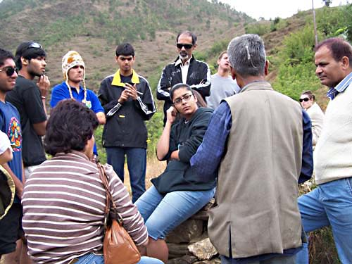
Farmer s inform students.

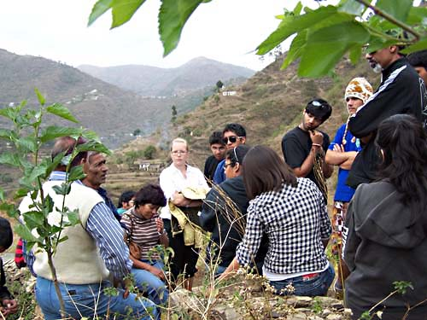

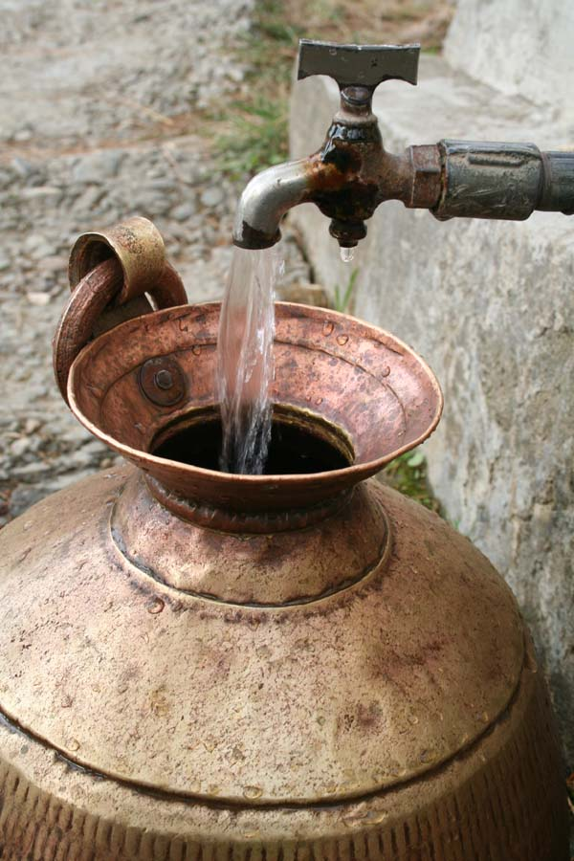
A traditional water carrying utensil locally called “banta”

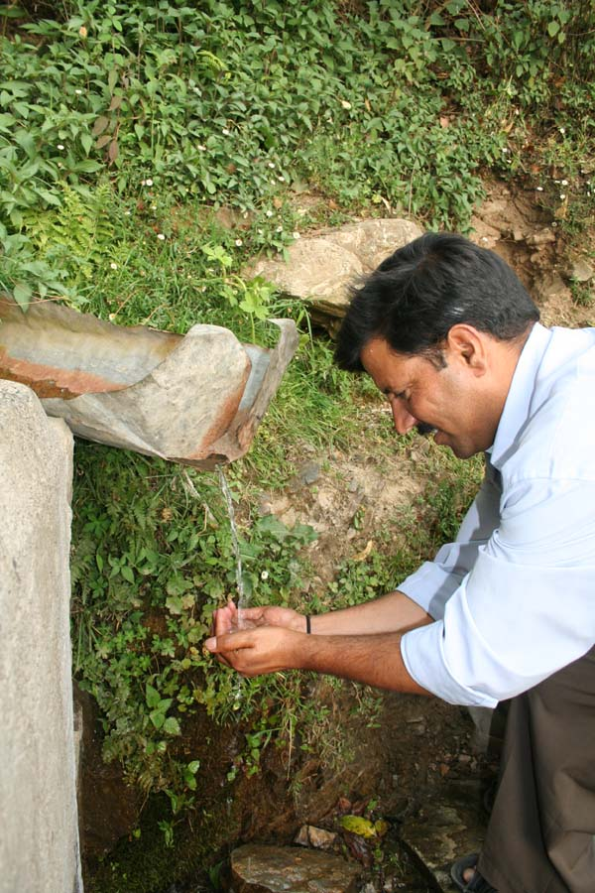
A ground water spring “fakva” maintained by local
community at Sabli.

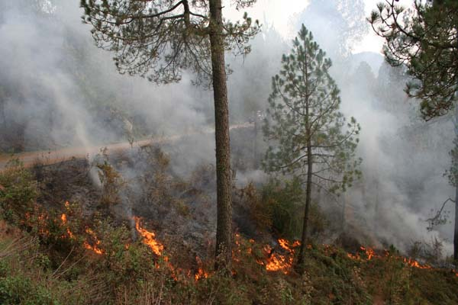 A forest fire at Sabli.

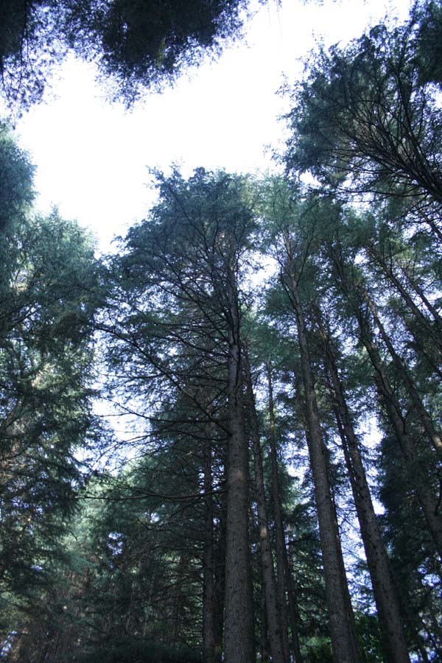
Oak forest near Sabli village.

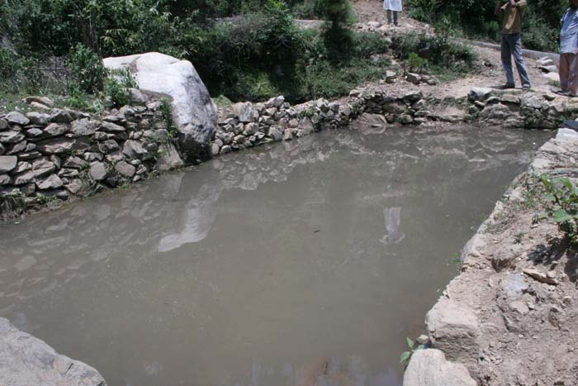
A chaal at Lowarkha. Uttarkashi.

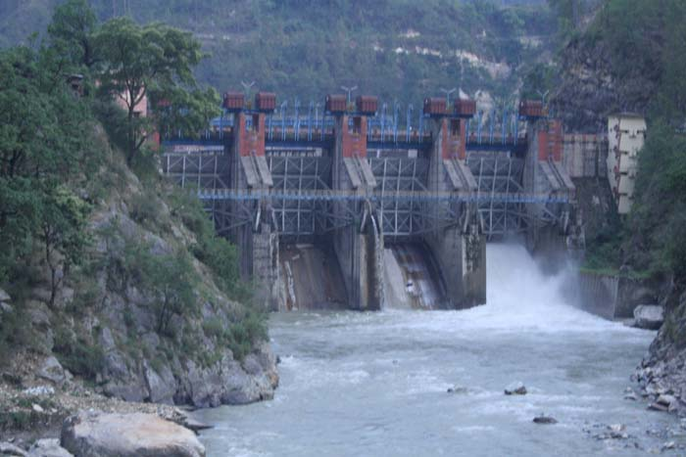
Maneri Bhali 1. A dam at Uttarkashi.

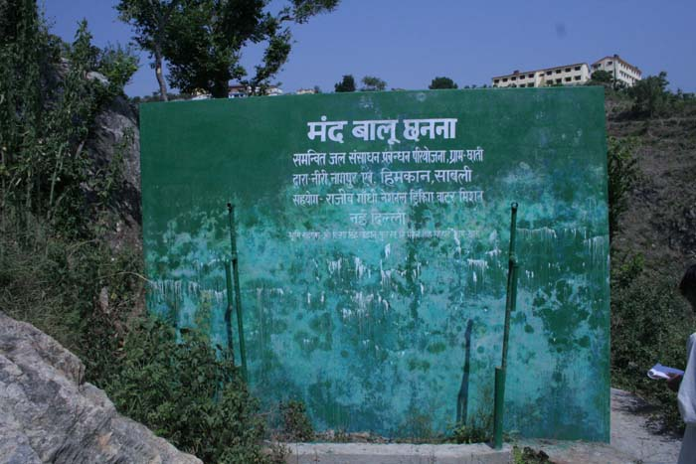

A Slow Sand Filter situated at Chaati Village in Tehri Garhwal.

