Walking With The Comrades

Arundhati Roy

OUTLOOK - March 29, 2010

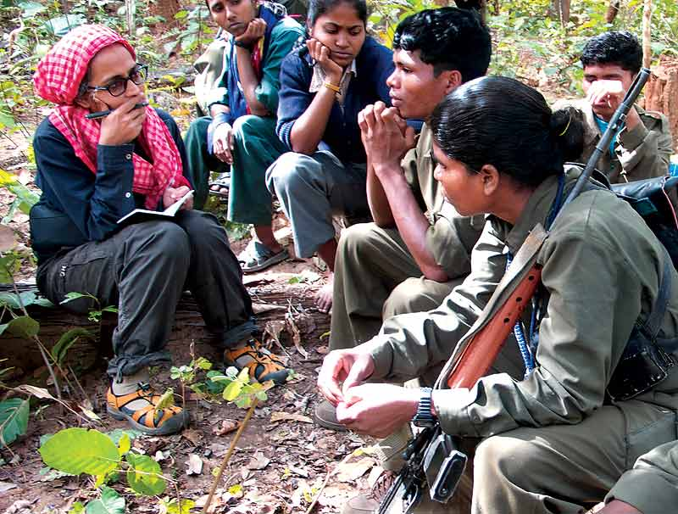
Dateline Dantewada: Roy with the Maoists

Gandhians with a Gun? Arundhati Roy plunges into the sea of Gondi people to find some answers...
The terse, typewritten note slipped under my door in a sealed envelope confirmed my appointment with India’s Gravest Internal Security Threat. I’d been waiting for months to hear from them. I had to be at the Ma Danteshwari mandir in Dantewada, Chhattisgarh, at any of four given times on two given days. That was to take care of bad weather, punctures, blockades, transport strikes and sheer bad luck. The note said: “Writer should have camera, tika and coconut. Meeter will have cap, Hindi Outlook magazine and bananas. Password: Namashkar Guruji.”
Namashkar Guruji. I wondered whether the Meeter and Greeter would be expecting a man. And whether I should get myself a moustache.
There are many ways to describe Dantewada. It’s an oxymoron. It’s a border town smack in the heart of India. It’s the epicentre of a war. It’s an upside down, inside out town.
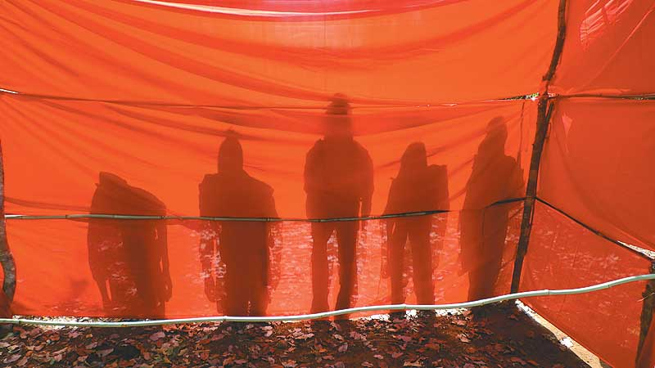
Red Shadow: Centenary celebrations of the adivasi uprising in Bastar; Sten gun at hand
In Dantewada, the police wear plain clothes and the rebels wear uniforms. The jail superintendent is in jail. The prisoners are free (three hundred of them escaped from the old town jail two years ago). Women who have been raped are in police custody. The rapists give speeches in the bazaar.
Across the Indravati river, in the area controlled by the Maoists, is the place the police call ‘Pakistan’. There the villages are empty, but the forest is full of people. Children who ought to be in school run wild. In the lovely forest villages, the concrete school buildings have either been blown up and lie in a heap, or they are full of policemen. The deadly war that is unfolding in the jungle is a war that the Government of India is both proud and shy of. Operation Green Hunt has been proclaimed as well as denied. P. Chidambaram, India’s home minister (and CEO of the war), says it does not exist, that it’s a media creation. And yet substantial funds have been allocated to it and tens of thousands of troops are being mobilised for it. Though the theatre of war is in the jungles of Central India, it will have serious consequences for us all.
If ghosts are the lingering spirits of someone, or something, that has ceased to exist, then perhaps the new four-lane highway crashing through the forest is the opposite of a ghost. Perhaps it is the harbinger of what is still to come.
The antagonists in the forest are disparate and unequal in almost every way. On one side is a massive paramilitary force armed with the money, the firepower, the media, and the hubris of an emerging Superpower. On the other, ordinary villagers armed with traditional weapons, backed by a superbly organised, hugely motivated Maoist guerrilla fighting force with an extraordinary and violent history of armed rebellion. The Maoists and the paramilitary are old adversaries and have fought older avatars of each other several times before: Telangana in the ’50s; West Bengal, Bihar, Srikakulam in Andhra Pradesh in the late ’60s and ’70s; and then again in Andhra Pradesh, Bihar and Maharashtra from the ’80s all the way through to the present. They are familiar with each other’s tactics, and have studied each other’s combat manuals closely. Each time, it seemed as though the Maoists (or their previous avatars) had been not just defeated, but literally, physically exterminated. Each time, they have re-emerged, more organised, more determined and more influential than ever. Today once again the insurrection has spread through the mineral-rich forests of Chhattisgarh, Jharkhand, Orissa and West Bengal—homeland to millions of India’s tribal people, dreamland to the corporate world.
It’s easier on the liberal conscience to believe that the war in the forests is a war between the Government of India and the Maoists, who call elections a sham, Parliament a pigsty and have openly declared their intention to overthrow the Indian State. It’s convenient to forget that tribal people in Central India have a history of resistance that predates Mao by centuries. (That’s a truism of course. If they didn’t, they wouldn’t exist.) The Ho, the Oraon, the Kols, the Santhals, the Mundas and the Gonds have all rebelled several times, against the British, against zamindars and moneylenders. The rebellions were cruelly crushed, many thousands killed, but the people were never conquered. Even after Independence, tribal people were at the heart of the first uprising that could be described as Maoist, in Naxalbari village in West Bengal (where the word Naxalite—now used interchangeably with ‘Maoist’—originates). Since then, Naxalite politics has been inextricably entwined with tribal uprisings, which says as much about the tribals as it does about the Naxalites.
In Dantewada, the police wear plain clothes, the rebels wear uniforms. The jail superintendent is in jail; the prisoners are free.

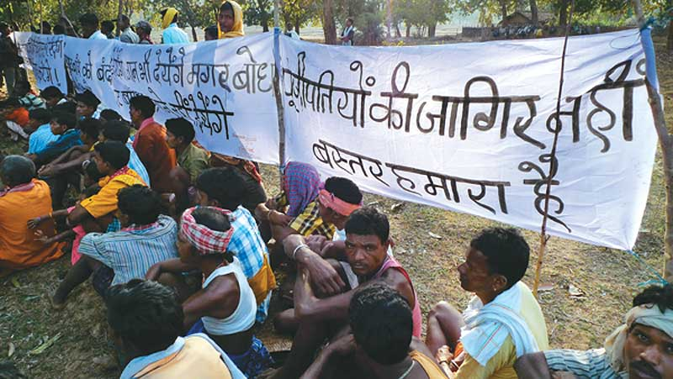
Staying Put: People of Kudur village protest the Bodhghat dam: ‘It does not belong to the capitalists, Bastar is Ours’y
This legacy of rebellion has left behind a furious people who have been deliberately isolated and marginalised by the Indian government. The Indian Constitution, the moral underpinning of Indian democracy, was adopted by Parliament in 1950. It was a tragic day for tribal people. The Constitution ratified colonial policy and made the State custodian of tribal homelands. Overnight, it turned the entire tribal population into squatters on their own land. It denied them their traditional rights to forest produce, it criminalised a whole way of life. In exchange for the right to vote, it snatched away their right to livelihood and dignity.
Having dispossessed them and pushed them into a downward spiral of indigence, in a cruel sleight of hand, the government began to use their own penury against them. Each time it needed to displace a large population—for dams, irrigation projects, mines—it talked of “bringing tribals into the mainstream” or of giving them “the fruits of modern development”. Of the tens of millions of internally displaced people (more than 30 million by big dams alone), refugees of India’s ‘progress’, the great majority are tribal people. When the government begins to talk of tribal welfare, it’s time to worry.
The most recent expression of concern has come from home minister P. Chidambaram who says he doesn’t want tribal people living in “museum cultures”. The well-being of tribal people didn’t seem to be such a priority during his career as a corporate lawyer, representing the interests of several major mining companies. So it might be an idea to enquire into the basis for his new anxiety.
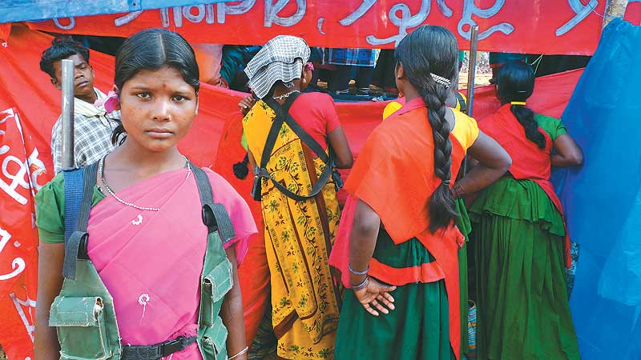
The Day of the Bhumkal: Face to face with "India's greatest Security Threat".
Over the past five years or so, the governments of Chhattisgarh, Jharkhand, Orissa and West Bengal have signed hundreds of MoUs with corporate houses, worth several billion dollars, all of them secret, for steel plants, sponge-iron factories, power plants, aluminium refineries, dams and mines. In order for the MoUs to translate into real money, tribal people must be moved.
Therefore, this war.
When a country that calls itself a democracy openly declares war within its borders, what does that war look like? Does the resistance stand a chance? Should it? Who are the Maoists? Are they just violent nihilists foisting an outdated ideology on tribal people, goading them into a hopeless insurrection? What lessons have they learned from their past experience? Is armed struggle intrinsically undemocratic? Is the Sandwich Theory—of ‘ordinary’ tribals being caught in the crossfire between the State and the Maoists—an accurate one? Are ‘Maoists’ and ‘Tribals’ two entirely discrete categories as is being made out? Do their interests converge? Have they learned anything from each other? Have they changed each other?
The day before I left, my mother called, sounding sleepy. “I’ve been thinking,” she said, with a mother’s weird instinct, “what this country needs is revolution.”
An article on the internet says that Israel’s Mossad is training 30 high-ranking Indian police officers in the techniques of targeted assassinations, to render the Maoist organisation “headless”. There’s talk in the press about the new hardware that has been bought from Israel: laser range-finders, thermal imaging equipment and unmanned drones, so popular with the US army. Perfect weapons to use against the poor.
The drive from Raipur to Dantewada takes about 10 hours through areas known to be ‘Maoist-infested’. These are not careless words. ‘Infest/infestation’ implies disease/pests. Diseases must be cured. Pests must be exterminated. Maoists must be wiped out. In these creeping, innocuous ways, the language of genocide has entered our vocabulary.
To protect the highway, security forces have ‘secured’ a narrow bandwidth of forest on either side. Further in, it’s the raj of the ‘Dada log’. The Brothers. The Comrades.
On the outskirts of Raipur, a massive billboard advertises Vedanta (the company our home minister once worked with) Cancer Hospital. In Orissa, where it is mining bauxite, Vedanta is financing a university. In these creeping, innocuous ways, mining corporations enter our imaginations: the Gentle Giants Who Really Care. It’s called CSR, Corporate Social Responsibility. It allows mining companies to be like the legendary actor and former chief minister NTR, who liked to play all the parts in Telugu mythologicals—the good guys and the bad guys, all at once, in the same movie. This CSR masks the outrageous economics that underpins the mining sector in India. For example, according to the recent Lokayukta report for Karnataka, for every tonne of iron ore mined by a private company, the government gets a royalty of Rs 27 and the mining company makes Rs 5,000. In the bauxite and aluminium sector, the figures are even worse. We’re talking about daylight robbery to the tune of billions of dollars. Enough to buy elections, governments, judges, newspapers, TV channels, NGOs and aid agencies. What’s the occasional cancer hospital here or there?
I don’t remember seeing Vedanta’s name on the long list of MoUs signed by the Chhattisgarh government. But I’m twisted enough to suspect that if there’s a cancer hospital, there must be a flat-topped bauxite mountain somewhere.
We pass Kanker, famous for its Counter Terrorism and Jungle Warfare College run by Brigadier B.K. Ponwar, Rumpelstiltskin of this war, charged with the task of turning corrupt, sloppy policemen (straw) into jungle commandos (gold). “Fight a guerrilla like a guerrilla”, the motto of the warfare training school, is painted on the rocks. The men are taught to run, slither, jump on and off air-borne helicopters, ride horses (for some reason), eat snakes and live off the jungle. The brigadier takes great pride in training street dogs to fight ‘terrorists’. Eight hundred policemen graduate from the warfare training school every six weeks. Twenty similar schools are being planned all over India. The police force is gradually being turned into an army. (In Kashmir, it’s the other way around. The army is being turned into a bloated, administrative police force.) Upside down. Inside out. Either way, the Enemy is the People.
It’s late. Jagdalpur is asleep, except for the many hoardings of Rahul Gandhi asking people to join the Youth Congress. He’s been to Bastar twice in recent months but hasn’t said anything much about the war. It’s probably too messy for the People’s Prince to meddle in at this point. His media managers must have put their foot down. The fact that the Salwa Judum—the dreaded, government-sponsored vigilante group responsible for rapes, killings, for burning down villages and driving hundreds of thousands of people from their homes—is led by Mahendra Karma, a Congress MLA, does not get much play in the carefully orchestrated publicity around Rahul Gandhi.
Tribal people in central India have a history of resistance predating Mao. The rebellions were crushed, but the people were never conquered.

I arrived at the Ma Danteshwari mandir well in time for my appointment (first day, first show). I had my camera, my small coconut and a powdery red tika on my forehead. I wondered if someone was watching me and having a laugh. Within minutes a young boy approached me. He had a cap and a backpack schoolbag. Chipped red nail-polish on his fingernails. No Hindi Outlook, no bananas. “Are you the one who’s going in?” he asked me. No Namashkar Guruji. I did not know what to say. He took out a soggy note from his pocket and handed it to me. It said, “Outlook nahin mila (couldn’t find Outlook).”
“And the bananas?”
“I ate them,” he said, “I got hungry.”
He really was a security threat.
His backpack said Charlie Brown—Not your ordinary blockhead. He said his name was Mangtu. I soon learned that Dandakaranya, the forest I was about to enter, was full of people who had many names and fluid identities. It was like balm to me, that idea. How lovely not to be stuck with yourself, to become someone else for a while.
We walked to the bus stand, only a few minutes away from the temple. It was already crowded. Things happened quickly. There were two men on motorbikes. There was no conversation—just a glance of acknowledgment, a shifting of body weight, the revving of engines. I had no idea where we were going. We passed the house of the Superintendent of Police (SP), which I recognised from my last visit. He was a candid man, the SP: “See Ma’am, frankly speaking this problem can’t be solved by us police or military. The problem with these tribals is they don’t understand greed. Unless they become greedy, there’s no hope for us. I have told my boss, remove the force and instead put a TV in every home. Everything will be automatically sorted out.”
In no time at all we were riding out of town. No tail. It was a long ride, three hours by my watch. It ended abruptly in the middle of nowhere, on an empty road with forest on either side. Mangtu got off. I did too. The bikes left, and I picked up my backpack and followed the small internal security threat into the forest. It was a beautiful day. The forest floor was a carpet of gold.
In a while we emerged on the white, sandy banks of a broad flat river. It was obviously monsoon-fed, so now it was more or less a sand flat, at the centre a stream, ankle deep, easy to wade across. Across was ‘Pakistan’. “Out there, ma’am,” the candid SP had said to me, “my boys shoot to kill.” I remembered that as we began to cross. I saw us in a policeman’s rifle-sights—tiny figures in a landscape, easy to pick off. But Mangtu seemed quite unconcerned, and I took my cue from him.
Waiting for us on the other bank, in a lime-green shirt that said Horlicks!, was Chandu. A slightly older security threat. Maybe twenty. He had a lovely smile, a cycle, a jerry can with boiled water and many packets of glucose biscuits for me, from the Party. We caught our breath and began to walk again. The cycle, it turned out, was a red herring. The route was almost entirely non-cycleable. We climbed steep hills and clambered down rocky paths along some pretty precarious ledges. When he couldn’t wheel it, Chandu lifted the cycle and carried it over his head as though it weighed nothing. I began to wonder about his bemused village boy air. I discovered (much later) that he could handle every kind of weapon, “except for an LMG”, he informed me cheerfully.
I’m surrounded by strange, beautiful children with their curious arsenal—all Maoists. Are they going to die? What for? To turn this into a mine?

Three beautiful, sozzled men with flowers in their turbans walked with us for about half an hour, before our paths diverged. At sunset, their shoulder bags began to crow. They had roosters in them, which they had taken to market but hadn’t managed to sell.
Chandu seems to be able to see in the dark. I have to use my torch. The crickets start up and soon there’s an orchestra, a dome of sound over us. I long to look up at the night sky, but I dare not. I have to keep my eyes on the ground. One step at a time. Concentrate.
I hear dogs. But I can’t tell how far away they are. The terrain flattens out. I steal a look at the sky. It makes me ecstatic. I hope we’re going to stop soon. “Soon,” Chandu says. It turns out to be more than an hour. I see silhouettes of enormous trees. We arrive.
The village seems spacious, the houses far away from each other. The house we enter is beautiful. There’s a fire, some people sitting around. More people outside, in the dark. I can’t tell how many. I can just about make them out. A murmur goes around. Lal Salaam Kaamraid (Red Salute, Comrade). Lal Salaam, I say. I’m beyond tired. The lady of the house calls me inside and gives me chicken curry cooked in green beans and some red rice. Fabulous. Her baby is asleep next to me, her silver anklets gleam in the firelight.
After dinner, I unzip my sleeping bag. It’s a strange intrusive sound, the big zip. Someone puts on the radio. BBC Hindi service. The Church of England has withdrawn its funds from Vedanta’s Niyamgiri project, citing environmental degradation and rights violations of the Dongria Kondh tribe. I can hear cowbells, snuffling, shuffling, cattle-farting. All’s well with the world. My eyes close.
CSR. It allows corporates to play good guys and bad guys all at once. If Vedanta has a cancer hospital somewhere, a bauxite mountain can’t be far.

We’re up at five. On the move by six. In another couple of hours, we cross another river. We walk through some beautiful villages. Every village has a family of tamarind trees watching over it, like a clutch of huge, benevolent, gods. Sweet, Bastar tamarind. By 11, the sun is high, and walking is less fun. We stop at a village for lunch. Chandu seems to know the people in the house. A beautiful young girl flirts with him. He looks a little shy, maybe because I’m around. Lunch is raw papaya with masoor dal, and red rice. And red chilli powder. We’re going to wait for the sun to lose some of its vehemence before we start walking again. We take a nap in the gazebo. There is a spare beauty about the place. Everything is clean and necessary. No clutter. A black hen parades up and down the low mud wall. A bamboo grid stabilises the rafters of the thatched roof and doubles as a storage rack. There’s a grass broom, two drums, a woven reed basket, a broken umbrella and a whole stack of flattened, empty, corrugated cardboard boxes. Something catches my eye. I need my spectacles. Here’s what’s printed on the cardboard: Ideal Power 90 High Energy Emulsion Explosive (Class-2) SD CAT ZZ.
We start walking again at about two. In the village we are going to meet a Didi (Sister, Comrade) who knows what the next step of the journey will be. Chandu doesn’t. There is an economy of information too. Nobody is supposed to know everything. But when we reach the village, Didi isn’t there. There is no news of her. For the first time, I see a little cloud of worry settling over Chandu. A big one settles over me. I don’t know what the systems of communication are, but what if they’ve gone wrong?
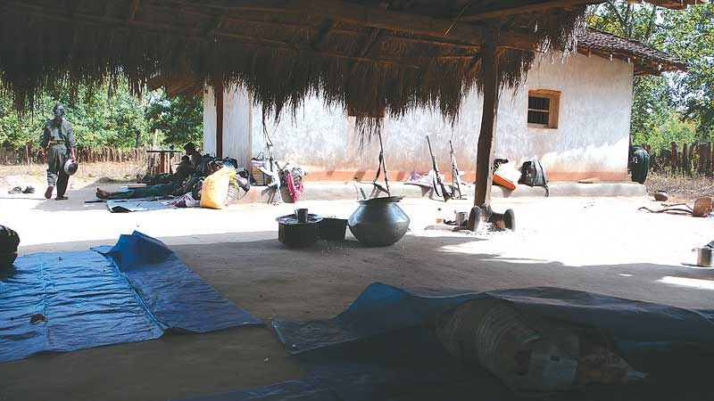
Spare Beauty: Pots, rifles, jhillies... Everything in these villages is clean and necessary
We’re parked outside a deserted school building, a little way out of the village. Why are all the government village schools built like concrete bastions, with steel shutters for windows and sliding folding steel doors? Why not like the village houses, with mud and thatch? Because they double up as barracks and bunkers. “In the villages in Abujhmad,” Chandu says, “schools are like this....” He scratches a building plan with a twig in the earth. Three octagons attached to each other like a honeycomb. “So they can fire in all directions.” He draws arrows to illustrate his point, like a cricket graphic—a batsman’s wagon wheel. There are no teachers in any of the schools, Chandu says. They’ve all run away. Or have you chased them away? No, we only chase police. But why should teachers come here, to the jungle, when they get their salaries sitting at home? Good point.
He informs me that this is a ‘new area’. The Party has entered only recently.
About 20 young people arrive, girls and boys. In their teens and early 20s. Chandu explains that this is the village-level militia, the lowest rung of the Maoists’ military hierarchy. I have never seen anyone like them before. They are dressed in saris and lungis, some in frayed olive-green fatigues. The boys wear jewellery, headgear. Every one of them has a muzzle-loading rifle, what’s called a bharmaar. Some also have knives, axes, a bow and arrow. One boy carries a crude mortar fashioned out of a heavy three-foot GI pipe. It’s filled with gunpowder and shrapnel and ready to be fired. It makes a big noise, but can only be used once. Still, it scares the police, they say, and giggle. War doesn’t seem to be uppermost on their minds. Perhaps because their area is outside the home range of the Salwa Judum. They have just finished a day’s work, helping to build fencing around some village houses to keep the goats out of the fields. They’re full of fun and curiosity. The girls are confident and easy with the boys. I have a sensor for this sort of thing, and I am impressed. Their job, Chandu says, is to patrol and protect a group of four or five villages and to help in the fields, clean wells or repair houses—doing whatever’s needed.
Still no Didi. What to do? Nothing. Wait. Help out with some chopping and peeling.
After dinner, without much talk, everybody falls in line. Clearly, we are moving. Everything moves with us, the rice, vegetables, pots and pans. We leave the school compound and walk single file into the forest. In less than half an hour, we arrive in a glade where we are going to sleep. There’s absolutely no noise. Within minutes everyone has spread their blue plastic sheets, the ubiquitous ‘jhilli’ (without which there will be no Revolution). Chandu and Mangtu share one and spread one out for me. They find me the best place, by the best grey rock. Chandu says he has sent a message to Didi. If she gets it, she will be here first thing in the morning. If she gets it.
It’s the most beautiful room I have slept in, in a long time. My private suite in a thousand-star hotel. I’m surrounded by these strange, beautiful children with their curious arsenal. They’re all Maoists for sure. Are they all going to die? Is the jungle warfare training school for them? And the helicopter gunships, the thermal imaging and the laser range-finders?
Why must they die? What for? To turn all of this into a mine? I remember my visit to the open cast iron-ore mines in Keonjhar, Orissa. There was forest there once. And children like these. Now the land is like a raw, red wound. Red dust fills your nostrils and lungs. The water is red, the air is red, the people are red, their lungs and hair are red. All day and all night trucks rumble through their villages, bumper to bumper, thousands and thousands of trucks, taking ore to Paradip port from where it will go to China. There it will turn into cars and smoke and sudden cities that spring up overnight. Into a ‘growth rate’ that leaves economists breathless. Into weapons to make war.
Everyone’s asleep except for the sentries who take one-and-a-half-hour shifts. Finally, I can look at the stars. When I was a child growing up on the banks of the Meenachal river, I used to think the sound of crickets—which always started up at twilight—was the sound of stars revving up, getting ready to shine. I’m surprised at how much I love being here. There is nowhere else in the world that I would rather be. Who should I be tonight? Kamraid Rahel, under the stars? Maybe Didi will come tomorrow.
Rahul’s been to Bastar twice in recent months, but has said nothing on the war. Perhaps it’s too messy for the People’s Prince at this point.

They arrive in the early afternoon. I can see them from a distance. About 15 of them, all in olive-green uniforms, running towards us. Even from a distance, from the way they run, I can tell they are the heavy hitters. The People’s Liberation Guerrilla Army (PLGA). For whom the thermal imaging and laser-guided rifles. For whom the jungle warfare training school.
They carry serious rifles, INSAS, SLR, two have AK-47s. The leader of the squad is Comrade Madhav who has been with the Party since he was nine. He’s from Warangal, Andhra Pradesh. He’s upset and extremely apologetic. There was a major miscommunication, he says again and again, which usually never happens. I was supposed to have arrived at the main camp on the very first night. Someone dropped the baton in the jungle-relay. The motorcycle drop was to have been at an entirely different place. “We made you wait, we made you walk so much. We ran all the way when the message came that you were here.” I said it was okay, that I had come prepared, to wait and walk and listen. He wants to leave immediately, because people in the camp were waiting, and worried.
It’s a few hours’ walk to the camp. It’s getting dark when we arrive. There are several layers of sentries and concentric circles of patrolling. There must be a hundred comrades lined up in two rows. Everyone has a weapon. And a smile. They begin to sing: Lal lal salaam, lal lal salaam, aane vaale saathiyon ko lal lal salaam (red salute to the comrades who have arrived). It is sung sweetly, as though it was a folk song about a river, or a forest blossom. With the song, the greeting, the handshake, and the clenched fist. Everyone greets everyone, murmuring Lalslaam, mlalslaa mlalslaam....
In April ’05, the Chhattisgarh government signed two MoUs for steel plants. The same month, the PM called Maoists the ‘gravest security threat’.

Other than a large blue jhilli spread out on the floor, about 15 feet square, there are no signs of a ‘camp’. This one has a jhilli roof as well. It’s my room for the night. I was either being rewarded for my days of walking, or being pampered in advance for what lay ahead. Or both. Either way it was the last time in the entire trip that I was going to have a roof over my head. Over dinner I meet Comrade Narmada, in charge of the Krantikari Adivasi Mahila Sangathan (KAMS), who has a price on her head; Comrade Saroja of the PLGA who is only as tall as her SLR; Comrade Maase (which means Black Girl in Gondi), who has a price on her head too; Comrade Rupi, the tech wizard; Comrade Raju, who’s in charge of the division I’d been walking through; and Comrade Venu (or Murali or Sonu or Sushil, whatever you would like to call him), clearly the seniormost of them all. Maybe central committee, maybe even politburo. I’m not told, I don’t ask. Between us we speak Gondi, Halbi, Telugu, Punjabi and Malayalam. Only Maase speaks English. (So we all communicate in Hindi!) Comrade Maase is tall and quiet and seems to have to swim through a layer of pain to enter the conversation. But from the way she hugs me, I can tell she’s a reader. And that she misses having books in the jungle. She will tell me her story only later. When she trusts me with her grief.
Bad news arrives, as it does in this jungle. A runner, with ‘biscuits’. Handwritten notes on sheets of paper, folded and stapled into little squares. There’s a bag full of them. Like chips. News from everywhere. The police have killed five people in Ongnaar village, four from the militia and one ordinary villager: Santhu Pottai (25), Phoolo Vadde (22), Kande Pottai (22), Ramoli Vadde (20), Dalsai Koram (22). They could have been the children in my star-spangled dormitory of last night.
Then good news arrives. A small contingent of people with a plump young man. He’s in fatigues too, but they look brand new. Everybody admires them and comments on the fit. He looks shy and pleased. He’s a doctor who has come to live and work with the comrades in the forest. The last time a doctor visited Dandakaranya was many years ago.
I remember my visit to the iron ore mines in Keonjhar. Once it had forest. Now the land’s like a raw, red wound. Red water, red air, red people.

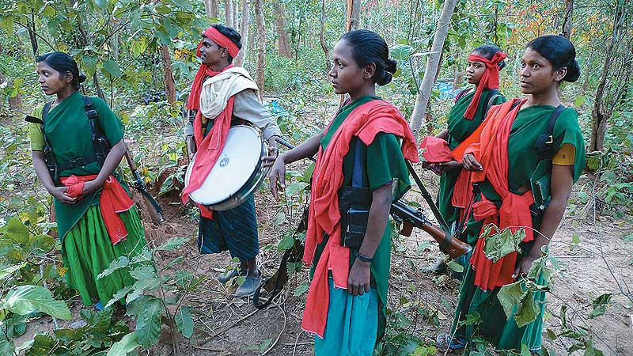
Performing Arts: Members of the Chetna Natya Manch, the cultural wing of the party, waiting in the wings
On the radio there’s news about the home minister’s meeting with chief ministers of states ‘affected by Left-Wing Extremism’. The chief ministers of Jharkhand and Bihar are being demure and have not attended. Everybody sitting around the radio laughs. Around the time of elections, they say, right through the campaign, and then maybe a month or two after the government is formed, mainstream politicians all say things like “Naxals are our children”. You can set your watch to the schedule of when they will change their minds, and grow fangs.
I am introduced to Comrade Kamla. I am told that I must on no account go even five feet away from my jhilli without waking her. Because everybody gets disoriented in the dark and could get seriously lost. (I don’t wake her. I sleep like a log.) In the morning Kamla presents me with a yellow polythene packet with one corner snipped off. Once it used to contain Abis Gold Refined Soya Oil. Now it was my Loo Mug. Nothing’s wasted on the Road to the Revolution.
(Even now I think of Comrade Kamla all the time, every day. She’s 17. She wears a homemade pistol on her hip. And boy, what a smile. But if the police come across her, they’ll kill her. They might rape her first. No questions will be asked. Because she’s an Internal Security Threat.)
After breakfast, Comrade Venu (Sushil, Sonu, Murali) is waiting for me, sitting cross-legged on the jhilli, looking for all the world like a frail village schoolteacher. I’m going to get a history lesson. Or, more accurately, a lecture on the history of the last 30 years in the Dandakaranya forest, which has culminated in the war that’s swirling through it today. For sure, it’s a partisan’s version. But then, what history isn’t? In any case, the secret history must be made public if it is to be contested, argued with, instead of merely being lied about, which is what is happening now.
Comrade Venu has a calm, reassuring manner and a gentle voice that will, in the days to come, surface in a context that will completely unnerve me. This morning he talks for several hours, almost continuously. He’s like a little store manager who has a giant bunch of keys with which to open up a maze of lockers full of stories, songs and insights.
Around the time of elections, mainstream netas say things like Naxals are our children. You can set your watch to when they’ll grow fangs.

Comrade Venu was in one of the seven armed squads who crossed the Godavari from Andhra Pradesh and entered the Dandakaranya forest (DK, in Partyspeak) in June 1980, 30 years ago. He is one of the original forty-niners. They belonged to People’s War Group (PWG), a faction of the Communist Party of India (Marxist-Leninist) or CPI(ML), the original Naxalites. PWG was formally announced as a separate, independent party in April that year, under Kondapalli Seetharamiah. PWG had decided to build a standing army, for which it would need a base. DK was to be that base, and those first squads were sent in to reconnoitre the area and begin the process of building guerrilla zones. The debate about whether communist parties ought to have a standing army, and whether or not a ‘people’s army’ is a contradiction in terms, is an old one. PWG’s decision to build an army came from its experience in Andhra Pradesh, where its ‘Land to the Tiller’ campaign led to a direct clash with the landlords, and resulted in the kind of police repression that the party found impossible to withstand without a trained fighting force of its own.
(By 2004, PWG had merged with the other CPI(ML) factions, Party Unity (PU) and the Maoist Communist Centre (MCC)—which functions for the most part out of Bihar and Jharkhand. To become what it is now, the Communist Party of India-Maoist.)
Dandakaranya is part of what the British, in their White Man’s way, called Gondwana, land of the Gonds. Today the state boundaries of Madhya Pradesh, Chhattisgarh, Orissa, Andhra Pradesh and Maharashtra slice through the forest. Breaking up a troublesome people into separate administrative units is an old trick. But these Maoists and Maoist Gonds don’t pay much attention to things like state boundaries. They have different maps in their heads, and like other creatures of the forest, they have their own paths. For them, roads are not meant for walking on. They’re meant only to be crossed, or as is increasingly becoming the case, ambushed. Though the Gonds (divided between the Koya and Dorla tribes) are by far the biggest majority, there are small settlements of other tribal communities too. The non-adivasi communities, traders and settlers, live on the edges of the forest, near the roads and markets.
The PWG were not the first evangelicals to arrive in Dandakaranya. Baba Amte, the well-known Gandhian, had opened his ashram and leprosy hospital in Warora in 1975. The Ramakrishna Mission had begun opening village schools in the remote forests of Abujhmad. In north Bastar, Baba Bihari Das had started an aggressive drive to “bring tribals back into the Hindu fold”, which involved a campaign to denigrate tribal culture, induce self-hatred, and introduce Hinduism’s great gift—caste. The first converts, the village chiefs and big landlords—people like Mahendra Karma, founder of the Salwa Judum—were conferred the status of Dwij, twice-born, Brahmins. (Of course, this was a bit of a scam, because nobody can become a Brahmin. If they could, we’d be a nation of Brahmins by now.) But this counterfeit Hinduism is considered good enough for tribal people, just like the counterfeit brands of everything else—biscuits, soap, matches, oil—that are sold in village markets. As part of the Hindutva drive, the names of villages were changed in land records, as a result of which most have two names now, people’s names and government names. Innar village, for example, became Chinnari. On voters’ lists, tribal names were changed to Hindu names. (Massa Karma became Mahendra Karma.) Those who did not come forward to join the Hindu fold were declared ‘Katwas’ (by which they meant untouchables) who later became the natural constituency for the Maoists.
The PWG first began work in south Bastar and Gadchiroli. Comrade Venu describes those first months in some detail: how the villagers were suspicious of them, and wouldn’t let them into their homes. No one would offer them food or water. The police spread rumours that they were thieves. The women hid their jewellery in the ashes of their wood stoves. There was an enormous amount of repression. In November 1980, in Gadchiroli, the police opened fire at a village meeting and killed an entire squad. That was DK’s first ‘encounter’ killing. It was a traumatic setback, and the comrades retreated across the Godavari and returned to Adilabad but in 1981 they returned. They began to organise tribal people to demand a rise in the price they were being paid for tendu leaves (which are used to make beedis). At the time, traders paid three paise for a bundle of about 50 leaves. It was a formidable job to organise people entirely unfamiliar with this kind of politics, to lead them on strike. Eventually the strike was successful and the price was doubled, to six paise a bundle. But the real success for the party was to have been able to demonstrate the value of unity and a new way of conducting a political negotiation. Today, after several strikes and agitations, the price of a bundle of tendu leaves is Re 1. (It seems a little improbable at these rates, but the turnover of the tendu business runs into hundreds of crores of rupees.) Every season, the government floats tenders and gives contractors permission to extract a fixed volume of tendu leaves—usually between 1,500 and 5,000 standard bags known as manak boras. Each manak bora contains about 1,000 bundles. (Of course, there’s no way of ensuring that the contractors don’t extract more than they’re meant to.) By the time the tendu enters the market, it is sold in kilos. The slippery arithmetic and the sly system of measurement that converts bundles into manak boras into kilos is controlled by the contractors, and leaves plenty of room for manipulation of the worst kind. The most conservative estimate puts their profit per standard bag at about Rs 1,100. (That’s after paying the party a commission of Rs 120 per bag.) Even by that gauge, a small contractor (1,500 bags) makes about Rs 16 lakh a season and a big one (5,000 bags) upto Rs 55 lakh. A more realistic estimate would be several times this amount. Meanwhile, the Gravest Internal Security Threat makes just enough to stay alive until the next season.
These Maoists and Maoist Gonds don’t pay attention to things like state boundaries. They have different maps in their heads, their own paths.

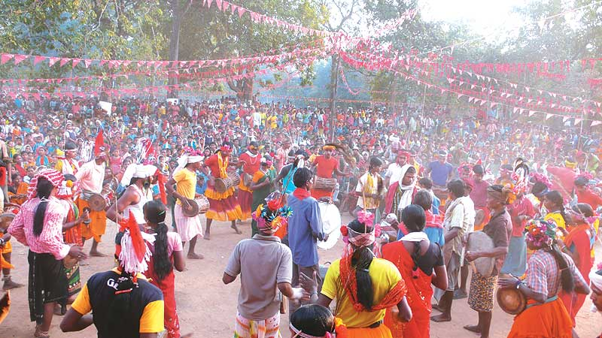
Gathered Storm: Dance troupes of various Janatana Sarkars perform on Bhumkal Day
We’re interrupted by some laughter and the sight of Nilesh, one of the young PLGA comrades, walking rapidly towards the cooking area, slapping himself. When he comes closer, I see that he’s carrying a leafy nest of angry red ants that have crawled all over him and are biting him on his arms and neck. Nilesh is laughing too. “Have you ever eaten ant chutney?” Comrade Venu asks me. I know red ants well, from my childhood in Kerala, I’ve been bitten by them, but I’ve never eaten them. (The chapoli turns out to be nice. Sour. Lots of folic acid.)
Nilesh is from Bijapur, which is at the heart of Salwa Judum operations. Nilesh’s younger brother joined the Judum on one of its looting and burning sprees and was made a Special Police Officer (SPO). He lives in the Basaguda camp with his mother. His father refused to go and stayed behind in the village. In effect, it’s a family blood feud. Later on, when I had an opportunity to talk to him, I asked Nilesh why his brother had done that. “He was very young,” Nilesh said, “he got an opportunity to run wild and hurt people and burn houses. He went crazy, did terrible things. Now he is stuck. He can never come back to the village. He will not be forgiven. He knows that.”
We return to the history lesson. The party’s next big struggle, Comrade Venu says, was against the Ballarpur Paper Mills. The government had given the Thapars a 45-year contract to extract 1.5 lakh tonnes of bamboo at a hugely subsidised rate. (Small beer compared to bauxite, but still.) The tribals were paid 10 paise for a bundle which contained 20 culms of bamboo. (I won’t yield to the vulgar temptation of comparing that with the profits the Thapars were making.) A long agitation, a strike, followed by negotiations with officials of the paper mill in the presence of the people, tripled the price to 30 paise per bundle. For the tribal people, these were huge achievements. Other political parties had made promises, but showed no signs of keeping them. People began to approach the PWG asking if they could join up.
But the politics of tendu, bamboo and other forest produce was seasonal. The perennial problem, the real bane of people’s lives, was the biggest landlord of all, the Forest Department. Every morning, forest officials, even the most junior of them, would appear in villages like a bad dream, preventing people from ploughing their fields, collecting firewood, plucking leaves, picking fruit, grazing their cattle, from living. They brought elephants to overrun fields and scattered babool seeds to destroy the soil as they passed by. People would be beaten, arrested, humiliated, their crops destroyed. Of course, from the forest department’s point of view, these were illegal people engaged in unconstitutional activity, and the department was only implementing the Rule of Law. (Their sexual exploitation of women was just an added perk in a hardship posting.)
Emboldened by the people’s participation in these struggles, the party decided to confront the forest department. It encouraged people to take over forest land and cultivate it. The forest department retaliated by burning new villages that came up in forest areas. In 1986, it announced a National Park in Bijapur, which meant the eviction of 60 villages. More than half of them had already been moved out, and construction of national park infrastructure had begun when the party moved in. It demolished the construction and stopped the eviction of the remaining villages. It prevented the forest department from entering the area. On a few occasions, officials were captured, tied to trees and beaten by villagers. It was cathartic revenge for generations of exploitation. Eventually, the forest department fled. Between 1986 and 2000, the party redistributed 3,00,000 acres of forest land. Today, Comrade Venu says, there are no landless peasants in Dandakaranya.
For today’s generation of young people, the forest department is a distant memory, the stuff of stories mothers tell their children, about a mythological past of bondage and humiliation. For the older generation, freedom from the forest department meant genuine freedom. They could touch it, taste it. It meant far more than India’s Independence ever did. They began to rally to the party that had struggled with them.
The seven-squad team had come a long way. Its influence now ranged across a 60,000 sq km stretch of forest, thousands of villages and millions of people.
But the departure of the forest department heralded the arrival of the police. That set off a cycle of bloodshed. Fake ‘encounters’ by the police, ambushes by the PWG. With the redistribution of land came other responsibilities: irrigation, agricultural productivity and the problem of an expanding population arbitrarily clearing forest land. A decision was taken to separate ‘mass work’ and ‘military work’.
Today, Dandakaranya is administered by an elaborate structure of Janatana Sarkars (people’s governments). The organising principles came from the Chinese revolution and the Vietnam war. Each Janatana Sarkar is elected by a cluster of villages whose combined population can range from 500 to 5,000. It has nine departments: Krishi (agriculture), Vyapar-Udyog (trade and industry) Arthik (economic), Nyay (justice), Raksha (defence), Hospital (health), Jan Sampark (public relations), School-Riti Rivaj (education and culture), and Jungle. A group of Janatana Sarkars come under an Area Committee. Three area committees make up a Division. There are 10 divisions in Dandakaranya.
“We have a Save the Jungle department now,” Comrade Venu says. “You must have read the government report that says forest has increased in Naxal areas?”
Ironically, Comrade Venu says, the first people to benefit from the party’s campaign against the forest department were the mukhias (village chiefs)—the Dwij brigade. They used their manpower and their resources to grab as much land as they could while the going was good. But then people began to approach the party with their “internal contradictions”, as Comrade Venu put it quaintly. The party began to turn its attention to issues of equity, class and injustice within tribal society. The big landlords sensed trouble on the horizon. As the party’s influence expanded, theirs had begun to wane. Increasingly, people were taking their problems to the party instead of to the mukhias. Old forms of exploitation began to be challenged. On the day of the first rain, people were traditionally supposed to till the mukhia’s land instead of their own. That stopped. They no longer offered them the first day’s picking of mahua or other forest produce. Obviously, something needed to be done.
Enter Mahendra Karma, one of the biggest landlords in the region and at the time a member of the Communist Party of India (CPI). In 1990, he rallied a group of mukhias and landlords and started a campaign called the Jan Jagran Abhiyaan (public awakening campaign). Their way of ‘awakening’ the ‘public’ was to form a hunting party of about 300 men to comb the forest, killing people, burning houses and molesting women. The then Madhya Pradesh government—Chhattisgarh had not yet been created—provided police back-up. In Maharashtra, something similar called ‘Democratic Front’ began its assault. People’s War responded to all of this in true People’s War style, by killing a few of the most notorious landlords. In a few months, the Jan Jagran Abhiyaan, the ‘white terror’—Comrade Venu’s term for it—faded. In 1998, Mahendra Karma, who had by now joined the Congress party, tried to revive the Jan Jagran Abhiyaan. This time it fizzled out even faster than before.
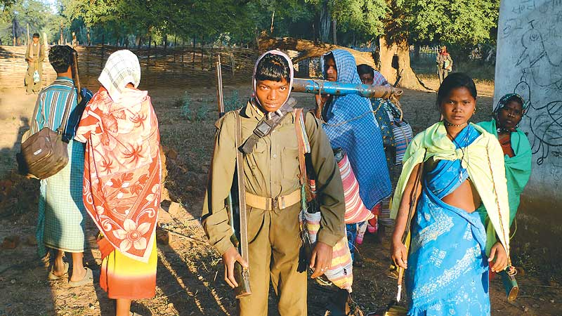
Armed Strugglers: A village militia, the ‘base force’ of the People’s Liberation Guerrilla Army
Then, in the summer of 2005, fortune favoured him. In April, the BJP government in Chhattisgarh signed two MoUs to set up integrated steel plants (the terms of which are secret). One for Rs 7,000 crore with Essar Steel in Bailadila, and the other for Rs 10,000 crore with Tata Steel in Lohandiguda. That same month, Prime Minister Manmohan Singh made his famous statement about the Maoists being the “Gravest Internal Security Threat” to India. (It was an odd thing to say at the time, because actually the opposite was true. The Congress government in Andhra Pradesh had just outmanoeuvred the Maoists, decimated them. They had lost about 1,600 of their cadre and were in complete disarray.) The PM’s statement sent the share value of mining companies soaring. It also sent a signal to the media that the Maoists were fair game for anyone who chose to go after them. In June 2005, Mahendra Karma called a secret meeting of mukhias in Kutroo village and announced the Salwa Judum (the Purification Hunt). A lovely melange of tribal earthiness and Dwij/Nazi sentiment.
Unlike the Jan Jagran Abhiyaan, the Salwa Judum was a ground-clearing operation, meant to move people out of their villages into roadside camps, where they could be policed and controlled. In military terms, it’s called Strategic Hamleting. It was devised by General Sir Harold Briggs in 1950 when the British were at war against the communists in Malaya. The Briggs Plan became very popular with the Indian army, which has used it in Nagaland, Mizoram and in Telangana. The BJP chief minister of Chhattisgarh, Raman Singh, announced that as far as his government was concerned, villagers who did not move into the camps would be considered Maoists. So, in Bastar, for an ordinary villager, just staying at home became the equivalent of indulging in dangerous terrorist activity.
Along with a steel mug of black tea, as a special treat, someone hands me a pair of earphones and switches on a little MP3 player. It’s a scratchy recording of Mr Manhar, the then SP Bijapur, briefing a junior officer over the wireless about the rewards and incentives the state and central governments are offering to ‘jagrit’ (awakened) villages, and to people who agree to move into camps. He then gives clear instructions that villages that refuse to surrender should be burnt and journalists who want to ‘cover’ Naxalites should be shot on sight. (I’d read about this in the papers long ago. When the story broke, as punishment—it’s not clear to whom—the SP was transferred to the State Human Rights Commission.)
The first village the Salwa Judum burnt (on June 18, 2005) was Ambeli. Between June and December 2005, it burned, killed, raped and looted its way through hundreds of villages of south Dantewada. The centre of its operations were the districts of Bijapur and Bhairamgarh, near Bailadila, where Essar Steel’s new plant was proposed. Not coincidentally, these were also Maoist strongholds, where the Janatana Sarkars had done a great deal of work, especially in building water-harvesting structures. The Janatana Sarkars became the special target of the Salwa Judum’s attacks. Hundreds of people were killed in the most brutal ways. About 60,000 people moved into camps, some voluntarily, others out of terror. Of these, about 3,000 were appointed SPOs on a salary of Rs 1,500.
For these paltry crumbs, young people, like Nilesh’s brother, have sentenced themselves to a life-sentence in a barbed wire enclosure. Cruel as they have been, they could end up being the worst victims of this horrible war. No Supreme Court judgement ordering the Salwa Judum to be dismantled can change their fate.
The remaining hundreds of thousands of people went off the government radar. (But the development funds for these 644 villages did not. What happens to that little goldmine?) Many of them made their way to Andhra Pradesh and Orissa where they usually migrated to work as contract labour during the chilli-picking season. But tens of thousands fled into the forest, where they still remain, living without shelter, coming back to their fields and homes only in the daytime.
In the slipstream of the Salwa Judum, a swarm of police stations and camps appeared. The idea was to provide carpet security for a ‘creeping reoccupation’ of Maoist-controlled territory. The assumption was that the Maoists would not dare to attack such a large concentration of security forces. The Maoists, for their part, realised that if they did not break that carpet security, it would amount to abandoning people whose trust they had earned, and with whom they had lived and worked for 25 years. They struck back in a series of attacks on the heart of the security grid.
On January 26, 2006, the PLGA attacked the Gangalaur police camp and killed seven people. On July 17, 2006, the Salwa Judum camp at Erabor was attacked, 20 people were killed and 150 injured. (You might have read about it: “Maoists attacked the relief camp set up by the state government to provide shelter to the villagers who had fled from their villages because of terror unleashed by the Naxalites.”) On December 13, 2006, they attacked the Basaguda ‘relief’ camp and killed three SPOs and a constable. On March 15, 2007, came the most audacious of them all. One hundred and twenty PLGA guerrillas attacked the Rani Bodili Kanya Ashram, a girls’ hostel that had been converted into a barrack for 80 Chhattisgarh Police (and SPOs) while the girls still lived in it as human shields. The PLGA entered the compound, cordoned off the annexe in which the girls lived, and attacked the barracks. Some 55 policemen and SPOs were killed. None of the girls was hurt. (The candid SP of Dantewada had shown me his PowerPoint presentation with horrifying photographs of the burned, disembowelled bodies of the policemen amidst the ruins of the blown-up school building. They were so macabre, it was impossible not to look away. He looked pleased at my reaction.)
The attack on Rani Bodili caused an uproar in the country. Human rights organisations condemned the Maoists not just for their violence, but also for being anti-education and attacking schools. But in Dandakaranya, the Rani Bodili attack became a legend: songs, poems and plays were written about it.
The Maoist counter-offensive did break the carpet security and gave people breathing space. The police and the Salwa Judum retreated into their camps, from which they now emerge—usually in the dead of night—only in packs of 300 or 1,000 to carry out cordon and search operations in villages. Gradually, except for the SPOs and their families, the rest of the people in the Salwa Judum camps began to return to their villages. The Maoists welcomed them back and announced that even SPOs could return if they genuinely, and publicly, regretted their actions. Young people began to flock to the PLGA. (The PLGA had been formally constituted in December 2000. Over the last 30 years, its armed squads had very gradually expanded into sections, sections had grown into platoons, and platoons into companies. But after the Salwa Judum’s depredations, the PLGA was rapidly able to declare battalion strength.)
The Salwa Judum had not just failed, it had backfired badly.
As we now know, it was not just a local operation by a small-time hood. Regardless of the doublespeak in the press, the Salwa Judum was a joint operation by the state government of Chhattisgarh and the Congress party which was in power at the Centre. It could not be allowed to fail. Not when all those MoUs were still waiting, like wilting hopefuls on the marriage market. The government was under tremendous pressure to come up with a new plan. They came up with Operation Green Hunt. The Salwa Judum SPOs are called Koya Commandos now. It has deployed the Chhattisgarh Armed Force (CAF), the Central Reserve Police Force (CRPF), the Border Security Force (BSF), the Indo-Tibetan Border Police (ITBP), the Central Industrial Security Force (CISF), Greyhounds, Scorpions, Cobras. And a policy that’s affectionately called WHAM—Winning Hearts and Minds.
We shouldn’t judge Charu Mazumdar too harshly. Especially not while we swaddle ourselves with Gandhi’s pious humbug.

Significant wars are often fought in unlikely places. Free Market Capitalism defeated Soviet Communism in the bleak mountains of Afghanistan. Here in the forests of Dantewada, a battle rages for the soul of India. Plenty has been said about the deepening crisis in Indian democracy and the collusion between big corporations, major political parties and the security establishment. If anybody wants to do a quick spot check, Dantewada is the place to go.
A draft report on State Agrarian Relations and the Unfinished Task of Land Reform (Volume 1) said that Tata Steel and Essar Steel were the first financiers of the Salwa Judum. Because it was a government report, it created a flurry when it was reported in the press. (That fact has subsequently been dropped from the final report. Was it a genuine error, or did someone receive a gentle, integrated steel tap on the shoulder?)
On October 12, 2009, the mandatory public hearing for Tata’s steel plant, meant to be held in Lohandiguda where local people could come, actually took place in a small hall inside the Collectorate in Jagdalpur, many miles away, cordoned off with massive security. A hired audience of 50 tribals was brought in a guarded convoy of government jeeps. After the meeting, the district collector congratulated ‘the people of Lohandiguda’ for their cooperation. The local newspapers reported the lie, even though they knew better. (The advertisements rolled in.) Despite villagers’ objections, land acquisition for the project has begun.
The Maoists are not the only ones who seek to depose the Indian State. It’s already been deposed several times by Hindu fundamentalism and economic totalitarianism.
Lohandiguda was never a Naxal area. The comrades moved in when graffiti saying ‘Naxali aao, hamein bachao’ began appearing on walls.

Lohandiguda, a five-hour drive from Dantewada, never used to be a Naxalite area. But it is now. Comrade Joori, who sat next to me while I ate the ant chutney, works in the area. She said they decided to move in after graffiti had begun to appear on the walls of village houses, saying, Naxali aao, hamein bachao (Naxals come and save us)! A few months ago, Vimal Meshram, president of the village panchayat, was shot dead in the market. “He was Tata’s man,” Joori says. “He was forcing people to give up their land and accept compensation. It’s good that he’s been finished. We lost a comrade too. They shot him. D’you want more chapoli?” She’s only 20. “We won’t let the Tatas come there. People don’t want them.” Joori is not PLGA. She’s in the Chetna Natya Manch (CNM), the cultural wing of the party. She sings. She writes songs. She’s from Abujhmad. (She’s married to Comrade Madhav. She fell in love with his singing when he visited her village with a CNM troupe.)
I feel I ought to say something at this point. About the futility of violence, about the unacceptability of summary executions. But what should I suggest they do? Go to court? Do a dharna at Jantar Mantar, New Delhi? A rally? A relay hunger strike? It sounds ridiculous. The promoters of the New Economic Policy—who find it so easy to say “There Is No Alternative”—should be asked to suggest an alternative Resistance Policy. A specific one, to these specific people, in this specific forest. Here. Now. Which party should they vote for? Which democratic institution in this country should they approach? Which door did the Narmada Bachao Andolan not knock on during the years and years it fought against Big Dams on the Narmada?
In true colonial fashion, they send Nagas and Mizos to fight in Chhattisgarh, the Sikhs to Kashmir, and the Tamilians to Assam.

It’s dark. There’s a lot of activity in the camp, but I can’t see anything. Just points of light moving around. It’s hard to tell whether they are stars or fireflies or Maoists on the move. Little Mangtu appears from nowhere. I found out that he’s part of the first batch of the Young Communists Mobile School, who are being taught to read and write and tutored in basic Communist principles. (“Indoctrination of young minds!” our corporate media howls. The TV advertisements that brainwash children before they can even think are not seen as a form of indoctrination.) The young Communists are not allowed to carry guns or wear uniforms. But they trail the PLGA squads, with stars in their eyes, like groupies of a rock band.
Mangtu has adopted me with a gently proprietorial air. He has filled my water bottle and says I should pack my bag. A whistle blows. The blue jhilli tent is dismantled and folded up in five minutes flat. Another whistle and all hundred comrades fall in line. Five rows. Comrade Raju is the Director of Ops. There’s a roll call. I’m in the line too, shouting out my number when Comrade Kamla who is in front of me, prompts me. (We count to twenty and then start from one, because that’s as far as most Gonds count. Twenty is enough for them. Maybe it should be enough for us too.) Chandu is in fatigues now, and carries a sten gun. In a low voice, Comrade Raju is briefing the group. It’s all in Gondi, I don’t understand a thing, but I keep hearing the word RV. Later Raju tells me it stands for Rendezvous! It’s a Gondi word now. “We make RV points so that in case we come under fire and people have to scatter, they know where to regroup.” He cannot possibly know the kind of panic this induces in me. Not because I’m scared of being fired on, but because I’m scared of being lost. I’m a directional dyslexic, capable of getting lost between my bedroom and my bathroom. What will I do in 60,000 square kilometres of forest? Come hell or high water, I’m going to be holding on to Comrade Raju’s pallu.
Before we start walking, Comrade Venu comes up to me: “Okaythen comrade. I’ll take your leave.” I’m taken aback. He looks like a little mosquito in a woollen cap and chappals, surrounded by his guards, three women, three men. Heavily armed. “We are very grateful to you comrade, for coming all the way here,” he says. Once again the handshake, the clenched fist. “Lal Salaam Comrade.” He disappears into the forest, the Keeper of the Keys. And in a moment, it’s as though he was never here. I’m a little bereft. But I have hours of recordings to listen to. And as the days turn into weeks, I will meet many people who paint colour and detail into the grid he drew for me. We begin to walk in the opposite direction. Comrade Raju, smelling of Iodex from a mile off, says with a happy smile, “My knees are gone. I can only walk if I have had a fistful of painkillers.”
Comrade Raju speaks perfect Hindi and has a deadpan way of telling the funniest stories. He worked as an advocate in Raipur for 18 years. Both he and his wife Malti were party members and part of its city network. At the end of 2007, one of the key people in the Raipur network was arrested, tortured and eventually turned informer. He was driven around Raipur in a closed police vehicle and made to point out his former colleagues. Comrade Malti was one of them. On January 22, 2008, she was arrested along with several others. The charge against her is that she mailed CDs containing video evidence of Salwa Judum atrocities to several members of Parliament. Her case rarely comes up for hearing because the police know their case is flimsy. But the new Chhattisgarh Special Public Security Act (CSPSA) allows the police to hold her without bail for several years. “Now the government has deployed several battalions of Chhattisgarh police to protect the poor members of Parliament from their own mail,” Comrade Raju says. He did not get caught because he was in Dandakaranya at the time, attending a meeting. He’s been here ever since. His two schoolgoing children, who were left alone at home, were interrogated extensively by the police. Finally, their home was packed up and they went to live with an uncle. Comrade Raju received news of them for the first time only a few weeks ago. What gives him this strength, this ability to hold on to his acid humour? What keeps them all going, despite all they have endured? Their faith and hope—and love—for the Party. I encounter it again and again, in the deepest, most personal ways.
Dandakaranya was full of people who had many names, fluid identities. It was balm to me, the idea. Not to be stuck with yourself, be someone else.

We’re moving in single file now. Myself and one hundred “senselessly violent”, bloodthirsty insurgents. I looked around at the camp before we left. There are no signs that almost a hundred people had camped here, except for some ash where the fires had been. I cannot believe this army. As far as consumption goes, it’s more Gandhian than any Gandhian, and has a lighter carbon footprint than any climate change evangelist. But for now, it even has a Gandhian approach to sabotage; before a police vehicle is burnt, for example, it is stripped down and every part cannibalised. The steering wheel is straightened out and made into a bharmaar, the rexine upholstery stripped and used for ammunition pouches, the battery for solar charging. (The new instructions from the high command are that captured vehicles should be buried and not cremated. So they can be resurrected when needed.) Should I write a play, I wonder—Gandhi Get Your Gun? Or will I be lynched?
We’re walking in pitch darkness and dead silence. I’m the only one using a torch, pointed down so that all I can see in its circle of light are Comrade Kamla’s bare heels in her scuffed, black chappals, showing me exactly where to put my feet. She is carrying 10 times more weight than I am. Her backpack, her rifle, a huge bag of provisions on her head, one of the large cooking pots and two shoulder bags full of vegetables. The bag on her head is perfectly balanced, and she can scramble down slopes and slippery rock pathways without so much as touching it. She is a miracle. It turns out to be a long walk. I’m grateful to the history lesson because apart from everything else it gave my feet a rest for a whole day. It’s the most beautiful thing, walking in the forest at night.
And I’ll be doing it night after night.
This army is more Gandhian than any Gandhian, even in sabotage. Before burning a police vehicle, it’s stripped down, the parts cannibalised.

We’re going to a celebration of the centenary of the 1910 Bhumkal rebellion in which the Koyas rose up against the British. Bhumkal means earthquake. Comrade Raju says people will walk for days together to come for the celebration. The forest must be full of people on the move. There are celebrations in all the DK divisions. We are privileged because Comrade Leng, the Master of Ceremonies, is walking with us. In Gondi, Leng means ‘the voice’. Comrade Leng is a tall, middle-aged man from Andhra Pradesh, a colleague of the legendary and beloved singer-poet Gadar, who founded the radical cultural organisation Jan Natya Manch (JNM) in 1972. Eventually, JNM became a formal part of the PWG and in Andhra Pradesh could draw audiences numbering in the tens of thousands. Comrade Leng joined in 1977 and became a famous singer in his own right. He lived in Andhra through the worst repression, the era of ‘encounter’ killings in which friends died almost every day. He himself was picked up one night from his hospital bed, by a woman Superintendent of Police masquerading as a doctor. He was taken to the forest outside Warangal to be ‘encountered’. But luckily, Gadar got the news and managed to raise an alarm. When the PW decided to start a cultural organisation in DK in 1998, Comrade Leng was sent to head the Chetna Natya Manch. And here he is now, walking with me, for some reason wearing an olive-green shirt and purple pyjamas with pink bunnies on them. “There are 10,000 members in CNM now,” he told me. “We have 500 songs, in Hindi, Gondi, Chhattisgarhi and Halbi. We have printed a book with 140 of our songs. Everybody writes songs.” The first time I spoke to him, he sounded very grave, very single-minded. But days later, sitting around a fire, still in those pyjamas, he tells us about a very successful, mainstream Telugu film director (a friend of his) who always plays a Naxalite in his own films. “I asked him,” Comrade Leng said in his lovely Telugu-accented Hindi, “why do you think Naxalites are always like this?”—and he did a deft caricature of a crouched, high-stepping, hunted-looking man emerging from the forest with an AK-47, and left us screaming with laughter.
I’m not sure whether I’m looking forward to the Bhumkal celebrations. I fear I’ll see traditional tribal dances stiffened by Maoist propaganda, rousing, rhetorical speeches and an obedient audience with glazed eyes. We arrive at the grounds quite late in the evening. A temporary monument, of bamboo scaffolding wrapped in red cloth, has been erected. On top, above the hammer and sickle of the Maoist Party, is the bow and arrow of the Janatana Sarkar, wrapped in silver foil. Appropriate, the hierarchy. The stage is huge, also temporary, on a sturdy scaffolding covered by a thick layer of mud plaster. Already, there are small fires scattered around the ground, people have begun to arrive and are cooking their evening meal. They’re only silhouettes in the dark. We thread our way through them (lalsalaam, lalsalaam, lalsalaam) and keep going for about 15 minutes until we re-enter the forest.
At our new campsite, we have to fall-in again. Another roll call. And then instructions about sentry positions and ‘firing arcs’—decisions about who will cover which area in the event of a police attack. RV points are fixed again.
Happiness is taken seriously in Dandakaranya. People walk for miles, for days, to sing and dance together. This is their defiance.

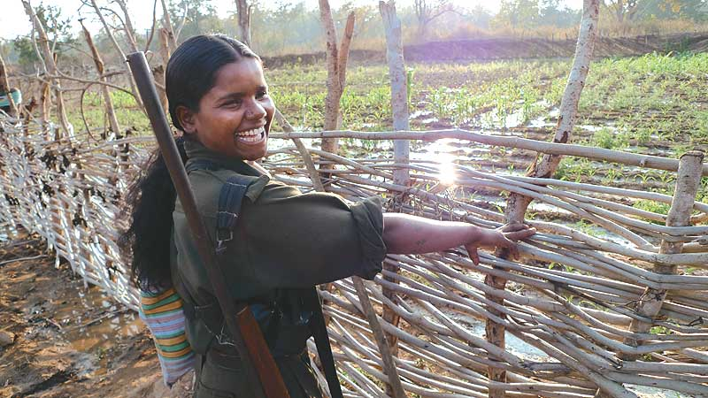
Boy, What A Smile: Comrade Kamla, 17, wearing a pistol on her hip. Also, a miracle.
An advance party has arrived and cooked dinner already. For dessert, Kamla brings me a wild guava that she has plucked on the walk and squirrelled away for me.
From dawn, there is the sense of more and more people gathering for the day’s celebration. There’s a buzz of excitement building up. People who haven’t seen each other in a long time meet again. We can hear the sound of mikes being tested. Flags, banners, posters, buntings are going up. A poster with the pictures of the five people who were killed in Ongnaar the day we arrived has appeared.
I’m drinking tea with Comrade Narmada, Comrade Maase and Comrade Rupi. Comrade Narmada talks about the many years she worked in Gadchiroli before becoming the DK head of the Krantikari Adivasi Mahila Sangathan. Rupi and Maase have been urban activists in Andhra Pradesh and tell me about the long years of struggle by women within the party, not just for their rights, but also to make the party see that equality between men and women is seen as central to a dream of a just society. We talk about the ’70s and the stories of women within the Naxalite movement who were disillusioned by male comrades who thought themselves great revolutionaries but were hobbled by the same old patriarchy, the same old chauvinism. Maase says things have changed a lot since then, though they still have a way to go. (The party’s central committee and politburo have no women yet.)
Around noon, another PLGA contingent arrives. This one is headed by a tall, lithe, boyish-looking man. This comrade has two names—Sukhdev, and Gudsa Usendi—neither of them his. Sukhdev is the name of a very beloved comrade who was martyred. (In this war, only the dead are safe enough to use their real names.) As for Gudsa Usendi, many comrades have been Gudsa Usendi at one point or another. (A few months ago, it was Comrade Raju.) Gudsa Usendi is the name of the party’s spokesperson for Dandakaranya. So even though Sukhdev spends the rest of the trip with me, I have no idea how I’d ever find him again. I’d recognise his laugh anywhere though. He came to DK in ’88, he says, when the PWG decided to send one-third of its forces from north Telangana into DK. He’s nicely dressed, in ‘civil’ (Gondi for ‘civilian clothes’) as opposed to ‘dress’ (the Maoist ‘uniform’) and could pass off as a young executive. I ask him why no uniform. He says he’s been travelling and has just come back from the Keshkal ghats near Kanker. There are reports of 3 million tonnes of bauxite that a company called Vedanta has its eye on.
Bingo. Ten on ten for my instincts.
Sukhdev says he went there to measure the people’s temperature. To see if they were prepared to fight. “They want squads now. And guns.” He throws his head back and roars with laughter, “I told them it’s not so easy, bhai.” From the stray wisps of conversation and the ease with which he carries his AK-47, I can tell he’s also high up and hands-on PLGA.
Jungle post arrives. There’s a biscuit for me! It’s from Comrade Venu. On a tiny piece of paper, folded and refolded, he has written down the lyrics of a song he promised he would send me. Comrade Narmada smiles when she reads them. She knows this story. It goes back to the ’80s, around the time when people first began to trust the party and come to it with their problems—their ‘inner contradictions’, as Comrade Venu put it. Women were among the first to come. One evening an old lady sitting by the fire got up and sang a song for the dada log. She was a Maadiya, among whom it was customary for women to remove their blouses and remain bare-breasted after they were married.
Jumper polo intor Dada, Dakoniley
Taane tasom intor Dada, Dakoniley
Bata papam kittom Dada, Dakoniley
Duniya kadile maata Dada, Dakoniley
(They say we cannot keep our
blouses, Dada, Dakoniley
They make us take them off, Dada,
In what way have we sinned, Dada,
The world’s changed, has it not Dada)
Aatum hatteke Dada, Dakoniley
Aada nanga dantom Dada, Dakoniley
Id pisval manni Dada, Dakoniley
Mava koyaturku vehat Dada, Dakoniley
(But when we go to market Dada,
We have to go half-naked Dada,
We don’t want this life Dada,
Tell our ancestors this Dada).
This was the first women’s issue the party decided to campaign against. It had to be handled delicately, with surgical tools. In 1986, it set up the Adivasi Mahila Sangathan (AMS) which evolved into the Krantikari Adivasi Mahila Sangathan and now has 90,000 enrolled members. It could well be the largest women’s organisation in the country. (They’re all Maoists by the way, all 90,000 of them. Are they going to be ‘wiped out’? And what about the 10,000 members of CNM? Them too?) KAMS campaigns against the adivasi traditions of forced marriage and abduction. Against the custom of making menstruating women live outside the village in a hut in the forest. Against bigamy and domestic violence. It hasn’t won all its battles, but then which feminists have? For instance, in Dandakaranya, even today women are not allowed to sow seeds. In party meetings, men agree that this is unfair and ought to be done away with. But, in practice, they simply don’t allow it. So, the party decided that women would sow seeds on common land which belongs to the Janatana Sarkar. On that land, they sow seed, grow vegetables and build check dams. A half-victory, not a whole one.
As police repression has grown in Bastar, the women of KAMS have become a formidable force and rally in their hundreds, sometimes thousands, to physically confront the police. The very fact that KAMS exists has radically changed traditional attitudes and eased many of the traditional forms of discrimination against women. For many young women, joining the party, in particular the PLGA, became a way of escaping the suffocation of their own society. Comrade Sushila, a senior office-bearer of KAMS talks about the Salwa Judum’s rage against KAMS women. She says one of their slogans was Hum do bibi layenge! Layenge! (We will have two wives! We will!). A lot of the rape and bestial sexual mutilation was directed at members of KAMS. Many young women who witnessed the savagery then joined the PLGA and now women make up 45 per cent of its cadre. Comrade Narmada sends for some of them and they join us in a while.
Comrade Rinki has very short hair. A bob-cut, as they say in Gondi. It’s brave of her, because here, ‘bob-cut’ means ‘Maoist’. For the police, that’s more than enough evidence to warrant summary execution. Comrade Rinki’s village, Korma, was attacked by the Naga battalion and the Salwa Judum in 2005. At that time, Rinki was part of the village militia. So were her friends Lukki and Sukki, who were also members of KAMS. After burning the village, the Naga battalion caught Lukki and Sukki and one other girl, gang-raped and killed them. “They raped them on the grass,” Rinki says, “but after it was over, there was no grass left.” It’s been years now, the Naga battalion has gone, but the police still come. “They come whenever they need women, or chickens.”
In most jan adalats, at least the collective is physically present to make a decision. It’s not made by judges who’ve lost touch with ordinary life.

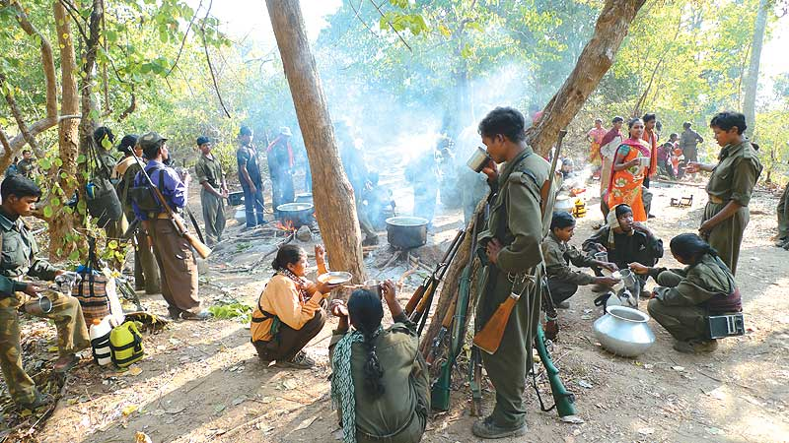
Rest Station: A Maoist ‘camp’. When they move, all that will remain is the ash from the kitchen fire.
Ajitha has a bob-cut too. The Judum came to Korseel, her village, and killed three people by drowning them in a nallah. Ajitha was with the militia and followed the Judum at a distance to a place close to the village called Paral Nar Todak. She watched them rape six women and shoot a man in his throat.
Comrade Laxmi, who is a beautiful girl with a long plait, tells me she watched the Judum burn 30 houses in her village, Jojor. “We had no weapons then,” she says, “we could do nothing but watch.” She joined the PLGA soon after. Laxmi was one of the 150 guerrillas who walked through the jungle for three-and-a-half months in 2008, to Nayagarh in Orissa, to raid a police armoury from where they captured 1,200 rifles and 2,00,000 rounds of ammunition.
Comrade Sumitra joined the PLGA in 2004, before the Salwa Judum began its rampage. She joined, she says, because she wanted to escape from home. “Women are controlled in every way,” she told me. “In our village, girls were not allowed to climb trees; if they did, they would have to pay a fine of Rs 500 or a hen. If a man hits a woman and she hits him back she has to give the village a goat. Men go off to the hills for months together to hunt. Women are not allowed to go near the kill, the best part of the meat goes to men. Women are not allowed to eat eggs.” Good reason to join a guerrilla army?
Sumitra tells the story of two of her friends, Telam Parvati and Kamla, who worked with KAMS. Telam Parvati was from Polekaya village in south Bastar. Like everyone else from there, she too watched the Salwa Judum burn her village. She then joined the PLGA and went to work in the Keshkal ghats. In 2009, she and Kamla had just finished organising the March 8 Women’s Day celebrations in the area. They were together in a little hut just outside a village called Vadgo. The police surrounded the hut at night and began to fire. Kamla fired back, but she was killed. Parvati escaped, but was found and killed the next day.
That’s what happened last year on Women’s Day. And here’s a press report from a national newspaper about Women’s Day this year:
Bastar rebels bat for women’s rights
Sahar Khan, Mail Today, Raipur, March 7, 2010
The government may have pulled out all stops to combat the Maoist menace in the country. But a section of rebels in Chhattisgarh has more pressing matters in hand than survival. With International Women’s Day around the corner, Maoists in the Bastar region of the state have called for week-long “celebrations” to advocate women’s rights. Posters were also put up in Bijapur, a part of Bastar district. The call by the self-styled champions of women’s rights has left the state police astonished. Inspector-general (IG) of Bastar, T.J. Longkumer said, “I have never seen such an appeal from the Naxalites, who believe only in violence and bloodshed.”
And then the report goes on to say:
“I think the Maoists are trying to counter our highly successful Jan Jagran Abhiyaan (mass awareness campaign). We started the ongoing campaign with an aim to win popular support for Operation Green Hunt, which was launched by the police to root out Left-wing extremists,” the IG said.
This cocktail of malice and ignorance is not unusual. Gudsa Usendi, chronicler of the party’s present, knows more about this than most people. His little computer and MP3 recorder are full of press statements, denials, corrections, party literature, lists of the dead, TV clips and audio and video material. “The worst thing about being Gudsa Usendi,” he says, “is issuing clarifications which are never published. We could bring out a thick book of our unpublished clarifications about the lies they tell about us.” He speaks without a trace of indignation, in fact, with some amusement.
“What’s the most ridiculous charge you’ve had to deny?”
He thinks back. “In 2007, we had to issue a statement saying, ‘Nahin bhai, hamne gai ko hathode se nahin mara (No brother, we did not kill the cows with a hammer).’ In 2007, the Raman Singh government announced a Gai Yojana (cow scheme), an election promise, a cow for every adivasi. One day the TV channels and newspapers reported that Naxalites had attacked a herd of cows and bludgeoned them to death—with hammers—because they were anti-Hindu, anti-BJP. You can imagine what happened. We issued a denial. Hardly anybody carried it. Later, it turned out that the man who had been given the cows to distribute was a rogue. He sold them and said we had ambushed him and killed the cows.”
And the most serious?
“Oh, there are dozens, they are running a campaign, after all. When the Salwa Judum started, the first day they attacked a village called Ambeli, burned it down and then all of them—SPOs, the Naga battalion, police—moved towards Kotrapal...you must have heard about Kotrapal? It’s a famous village, it has been burnt 22 times for refusing to surrender. When the Judum reached Kotrapal, our militia was waiting for it. They had prepared an ambush. Two SPOs died. We captured seven, the rest ran away. The next day the newspapers reported that the Naxalites had massacred poor adivasis. Some said we had killed hundreds. Even a respectable magazine like Frontline said we had killed 18 innocent adivasis. Even K. Balagopal, the human rights activist, who is usually meticulous about facts, even he said this. We sent a clarification. Nobody published it. Later, in his book, Balagopal acknowledged his mistake.... But who noticed?”
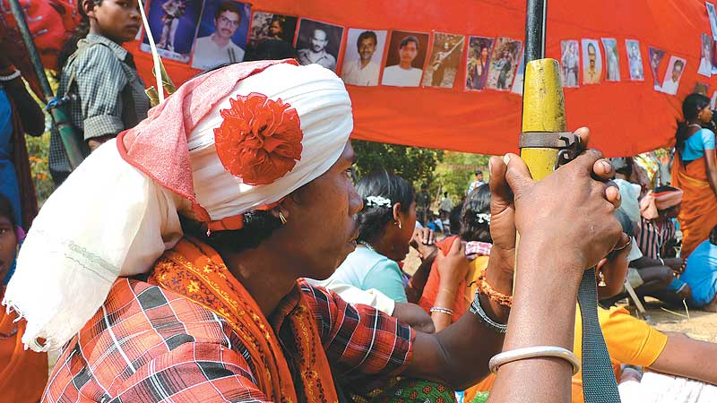
Remembering The Martyrs: Pictures of slain comrades displayed on Bhumkal Day
I asked what happened to the seven people who were captured. “The area committee called a jan adalat (people’s court). Four thousand people attended it. They listened to the whole story. Two of the SPOs were sentenced to death. Five were warned and let off. The people decided. Even with informers—which is becoming a huge problem nowadays—people listen to the case, the stories, the confessions and say, ‘Iska hum risk nahin le sakte (We’re not prepared to take the risk of trusting this person)’, or ‘Iska risk hum lenge (We are prepared to take the risk of trusting this person)’. The press always reports about informers who are killed. Never about the many who are let off. So everybody thinks it is some bloodthirsty procedure in which everybody is always killed. It’s not about revenge, it’s about survival and saving future lives.... Of course, there are problems, we’ve made terrible mistakes, we have even killed the wrong people in our ambushes thinking they were policemen, but it is not the way it’s portrayed in the media.”
The dreaded ‘People’s Courts’. How can we accept them? Or approve this form of rude justice?
On the other hand, what about ‘encounters’, fake and otherwise—the worst form of summary justice—that get policemen and soldiers bravery medals, cash awards and out-of-turn promotions from the Indian government? The more they kill, the more they are rewarded. ‘Bravehearts’, they are called, the ‘Encounter Specialists’. ‘Anti-nationals’, we are called, those of us who dare to question them. And what about the Supreme Court that brazenly admitted it did not have enough evidence to sentence Mohammed Afzal (accused in the December 2001 Parliament attack) to death, but did so anyway, because “the collective conscience of the society will only be satisfied if capital punishment is awarded to the offender”.
At least in the case of the Kotrapal jan adalat, the collective was physically present to make its own decision. It wasn’t made by judges who had lost touch with ordinary life a long time ago, presuming to speak on behalf of an absent collective.
What should the people of Kotrapal have done, I wonder? Sent for the police?
The sound of drums has become really loud. It’s Bhumkal time. We walk to the grounds. I can hardly believe my eyes. There is a sea of people, the most wild, beautiful people, dressed in the most wild, beautiful ways. The men seem to have paid much more attention to themselves than the women. They have feathered headgear and painted tattoos on their faces. Many have eye make-up and white, powdered faces. There’s lots of militia, girls in saris of breathtaking colours with rifles slung carelessly over their shoulders. There are old people, children, and red buntings arc across the sky. The sun is sharp and high. Comrade Leng speaks. And several office-holders of the various Janatana Sarkars. Comrade Niti, an extraordinary woman who has been with the party since 1997, is such a threat to the nation that in January 2007 more than 700 policemen surrounded Innar village because they heard she was there. Comrade Niti is considered to be so dangerous and is being hunted with such desperation not because she has led many ambushes (which she has), but because she is an adivasi woman who is loved by people in the village and is a real inspiration to young people. She speaks with her AK on her shoulder. (It’s a gun with a story. Almost everyone’s gun has a story: who it was snatched from, how, and by whom.)
A CNM troupe performs a play about the Bhumkal uprising. The evil white colonisers wear hats and golden straw for hair, and bully and beat adivasis to pulp—causing endless delight in the audience. Another troupe from south Gangalaur performs a play called Nitir Judum Pito (Story of the Blood Hunt). Joori translates for me. It’s the story of two old people who go looking for their daughter’s village. As they walk through the forest, they get lost because everything is burnt and unrecognisable. The Salwa Judum has even burned the drums and the musical instruments. There are no ashes because it has been raining. They cannot find their daughter. In their sorrow, the old couple starts to sing, and hearing them, the voice of their daughter sings back to them from the ruins: the sound of our village has been silenced, she sings. There’s no more pounding of rice, no more laughter by the well. No more birds, no more bleating goats. The taut string of happiness has been snapped.
Her father sings back: my beautiful daughter, don’t cry today. Everyone who is born must die. These trees around us will fall, flowers will bloom and fade, one day this world will grow old. But who are we dying for? One day our looters will learn, one day Truth will prevail, but our people will never forget you, not for thousands of years.
A few more speeches. Then the drumming and the dancing begins. Each Janatana Sarkar has its own troupe. Each troupe has prepared its own dance. They arrive one by one, with huge drums and they dance wild stories. The only character every troupe has in common is Bad Mining Man, with a helmet and dark glasses, and usually smoking a cigarette. But there’s nothing stiff, or mechanical, about their dancing. As they dance, the dust rises. The sound of drums becomes deafening. Gradually, the crowd begins to sway. And then it begins to dance. They dance in little lines of six or seven, men and women separate, with their arms around each other’s waists. Thousands of people. This is what they’ve come for. For this. Happiness is taken very seriously here, in the Dandakaranya forest. People will walk for miles, for days together to feast and sing, to put feathers in their turbans and flowers in their hair, to put their arms around each other and drink mahua and dance through the night. No one sings or dances alone. This, more than anything else, signals their defiance towards a civilisation that seeks to annihilate them.
I can’t believe all this is happening right under the noses of the police. Right in the midst of Operation Green Hunt.
At first, the PLGA comrades watch the dancers, standing aside with their guns. But then, one by one, like ducks who cannot bear to stand on the shore and watch other ducks swim, they move in and begin to dance too. Soon there are lines of olive-green dancers, swirling with all the other colours. And then, as sisters and brothers and parents and children and friends who haven’t met for months, years sometimes, encounter each other, the lines break up and re-form and the olive green is distributed among the swirling saris and flowers and drums and turbans. It surely is a People’s Army. For now, at least. And what Chairman Mao said about the guerrillas being the fish and people being the water they swim in, is, at this moment, literally true.
Chairman Mao. He’s here too. A little lonely, perhaps, but present. There’s a photograph of him, up on a red cloth screen. Marx too. And Charu Mazumdar, the founder and chief theoretician of the Naxalite Movement. His abrasive rhetoric fetishises violence, blood and martyrdom, and often employs a language so coarse as to be almost genocidal. Standing here, on Bhumkal day, I can’t help thinking that his analysis, so vital to the structure of this revolution, is so removed from its emotion and texture. When he said that only “an annihilation campaign” could produce “the new man who will defy death and be free from all thought of self-interest”—could he have imagined that this ancient people, dancing into the night, would be the ones on whose shoulders his dreams would come to rest?
‘Maoist-infested’. These are not careless words. Infest or infestation implies pests. Pests must be exterminated. Maoists must be wiped out.

It’s a great disservice to everything that is happening here that the only thing that seems to make it to the outside world is the stiff, unbending rhetoric of the ideologues of a party that has evolved from a problematic past. When Charu Mazumdar famously said, “China’s Chairman is our Chairman and China’s Path is Our Path,” he was prepared to extend it to the point where the Naxalites remained silent while General Yahya Khan committed genocide in East Pakistan (Bangladesh), because at the time, China was an ally of Pakistan. There was silence too, over the Khmer Rouge and its killing fields in Cambodia. There was silence over the egregious excesses of the Chinese and Russian revolutions. Silence over Tibet. Within the Naxalite movement too, there have been violent excesses and it’s impossible to defend much of what they’ve done. But can anything they have done compare with the sordid achievements of the Congress and the BJP in Punjab, Kashmir, Delhi, Mumbai, Gujarat.... And yet, despite these terrifying contradictions, Charu Mazumdar was a visionary in much of what he wrote and said. The party he founded (and its many splinter groups) has kept the dream of revolution real and present in India. Imagine a society without that dream. For that alone, we cannot judge him too harshly. Especially not while we swaddle ourselves with Gandhi’s pious humbug about the superiority of “the non-violent way” and his notion of trusteeship: “The rich man will be left in possession of his wealth, of which he will use what he reasonably requires for his personal needs and will act as a trustee for the remainder to be used for the good of society.”
How strange it is, though, that the contemporary tsars of the Indian Establishment—the State that crushed the Naxalites so mercilessly—should now be saying what Charu Mazumdar said so long ago: China’s Path is Our Path.
Upside Down. Inside Out.
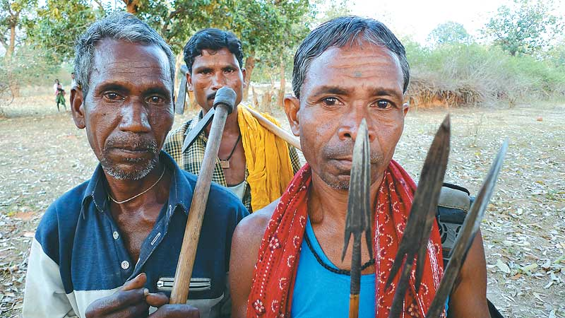
The Damned: Villagers from the submergence area of the proposed Bodhghat dam
China’s Path has changed. China has become an imperial power now, preying on other countries, other people’s resources. But the Party is still right, only, the Party has changed its mind.
When the Party is a suitor (as it is now in Dandakaranya), wooing the people, attentive to their every need, then it genuinely is a People’s Party, its army genuinely a People’s Army. But after the Revolution how easily this love affair can turn into a bitter marriage. How easily the People’s Army can turn upon the people. Today in Dandakaranya, the Party wants to keep the bauxite in the mountain. Tomorrow, will it change its mind? But can we, should we let apprehensions about the future immobilise us in the present?
The dancing will go on all night. I walk back to the camp. Maase is there, awake. We chat late into the night. I give her my copy of Neruda’s Captain’s Verses (I brought it along, just in case). She asks, again and again, “What do they think of us outside? What do students say? Tell me about the women’s movement, what are the big issues now?” She asks about me, my writing. I try and give her an honest account of my chaos. Then she starts to talk about herself, how she joined the party. She tells me that her partner was killed last May, in a fake encounter. He was arrested in Nashik, and taken to Warangal to be killed. “They must have tortured him badly.” She was on her way to meet him when she heard he had been arrested. She’s been in the forest ever since. After a long silence, she tells me she was married once before, years ago. “He was killed in an encounter too,” she says, and adds with heart-breaking precision, “but in a real one.”
I lie awake on my jhilli, thinking of Maase’s protracted sadness, listening to the drums and the sounds of protracted happiness from the grounds, and thinking about Charu Mazumdar’s idea of protracted war, the central precept of the Maoist Party. This is what makes people think the Maoists’ offer to enter ‘peace talks’ is a hoax, a ploy to get breathing space to regroup, re-arm themselves and go back to waging protracted war. What is protracted war? Is it a terrible thing in itself, or does it depend on the nature of the war? What if the people here in Dandakaranya had not waged their protracted war for the last 30 years, where would they be now?
And are the Maoists the only ones who believe in protracted war? Almost from the moment India became a sovereign nation, it turned into a colonial power, annexing territory, waging war. It has never hesitated to use military interventions to address political problems—Kashmir, Hyderabad, Goa, Nagaland, Manipur, Telangana, Assam, Punjab, the Naxalite uprising in West Bengal, Bihar, Andhra Pradesh and now across the tribal areas of Central India. Tens of thousands have been killed with impunity, hundreds of thousands tortured. All of this behind the benign mask of democracy. Who have these wars been waged against? Muslims, Christians, Sikhs, Communists, Dalits, Tribals and, most of all, against the poor who dare to question their lot instead of accepting the crumbs that are flung at them. It’s hard not to see that the Indian State is an essentially upper-caste Hindu State (regardless of the party in power) which harbours a reflexive hostility towards the ‘other’. One that, in true colonial fashion, sends the Nagas and Mizos to fight in Chhattisgarh, Sikhs to Kashmir, Kashmiris to Orissa, Tamilians to Assam and so on. If this isn’t protracted war, what is?
Unpleasant thoughts on a beautiful, starry night. Sukhdev is smiling to himself, his face lit by his computer screen. He’s a crazy workaholic. I ask him what’s funny. “I was thinking about the journalists who came last year for the Bhumkal celebrations. They came for a day or two. One posed with my AK, had himself photographed and then went back and called us Killing Machines or something.”
How strange that the contemporary tsars of the Indian establishment now say what Charu Mazumdar said: China’s Path is Our Path.

The dancing hasn’t stopped and it’s daybreak. The lines are still going, hundreds of young people still dancing. “They won’t stop,” Comrade Raju says, “not until we start packing up.”
On the grounds I run into Comrade Doctor. He’s been running a little medical camp on the edge of the dance floor. I want to kiss his fat cheeks. Why can’t he be at least 30 people instead of just one? Why can’t he be one thousand people? I ask him what it’s looking like, the health of Dandakaranya. His reply makes my blood run cold. Most of the people he has seen, he says, including those in the PLGA, have a haemoglobin count that’s between five and six (when the standard for Indian women is 11.) There’s TB caused by more than two years of chronic anaemia. Young children are suffering from Protein Energy Malnutrition Grade II, in medical terminology called Kwashiorkor. (I looked it up later. It’s a word derived from the Ga language of Coastal Ghana and means “the sickness a baby gets when the new baby comes”. Basically the old baby stops getting mother’s milk, and there’s not enough food to provide it nutrition.) “It’s an epidemic here, like in Biafra,” Comrade Doctor says, “I have worked in villages before, but I’ve never seen anything like this.”
Apart from this, there’s malaria, osteoporosis, tapeworm, severe ear and tooth infections and primary amenorrhea—which is when malnutrition during puberty causes a woman’s menstrual cycle to disappear, or never appear in the first place.
“There are no clinics in this forest apart from one or two in Gadchiroli. No doctors. No medicines.”
He’s off now, with his little team, on an eight-day trek to Abujhmad. He’s in ‘dress’ too, Comrade Doctor. So, if they find him, they’ll kill him.
Comrade Raju says that it isn’t safe for us to continue to camp here. We have to move. Leaving Bhumkal involves a lot of goodbyes spread over time.
Lal lal salaam, lal lal salaam,
Jaane wale saathiyon ko lal lal salaam
(Red Salute to departing comrades)
Phir milenge, phir milenge
Dandakaranya jungle mein phir milenge
(We’ll meet again, some day, in the Dandakaranya forest).
It’s never taken lightly, the ceremony of arrival and departure, because everybody knows that when they say “we’ll meet again” they actually mean “we may never meet again”.
Comrade Narmada, Comrade Maase and Comrade Rupi are going separate ways. Will I ever see them again?
So, once again, we walk. It’s becoming hotter every day. Kamla picks the first fruit of the tendu for me. It tastes like chikoo. I’ve become a tamarind fiend. This time we camp near a stream. Women and men take turns to bathe in batches. In the evening, Comrade Raju receives a whole packet of ‘biscuits’. News:
- 60 people arrested in Manpur Division at the end of Jan 2010 have not yet been produced in Court.
- Huge contingents of police have arrived in South Bastar. Indiscriminate attacks are on.
- On Nov 8, 2009, in Kachlaram Village, Bijapur Jila, Dirko Madka (60) and Kovasi Suklu (68) were killed
- On Nov 24, Madavi Baman (15) was killed in Pangodi village
- On Dec 3, Madavi Budram from Korenjad also killed
- On Dec 11, Gumiapal village, Darba Division, 7 people killed (names yet to come)
- On Dec 15, Kotrapal village, Veko Sombar and Madavi Matti (both with KAMS) killed
- On Dec 30, Vechapal village Poonem Pandu and Poonem Motu (father and son) killed
- On Jan 2010 (date unknown), head of the Janatana Sarkar in Kaika village, Gangalaur, killed
- On Jan 9, 4 people killed in Surpangooden village, Jagargonda Area
- On Jan 10, 3 people killed in Pullem Pulladi village (no names yet)
- On Jan 25, 7 people killed in Takilod village, Indravati Area
- On Feb 10 (Bhumkal Day), Kumli raped and killed in Dumnaar Village, Abujhmad. She was from a village called Paiver
- 2,000 troops of the Indo-Tibetan Border Police (ITBP) are camped in the Rajnandgaon forests
- 5,000 additional BSF troops have arrived in Kanker
And then:
- PLGA quota filled.
Some dated newspapers have arrived too. There’s a lot of press about Naxalites. One screaming headline sums up the political climate perfectly: ‘Khadedo, Maaro, Samarpan Karao (Eliminate, kill, make them surrender).’ Below that: ‘Vaarta ke liye loktantra ka dwar khula hai’ (Democracy’s door is always open for talks).’ A second says the Maoists are growing cannabis to make money. The third has an editorial saying that the area we’ve camped in and are walking through is entirely under police control.
The young Communists take the clips away to practice their reading. They walk around the camp reading the anti-Maoist articles loudly in radio-announcer voices.
New day. New place. We’re camped on the outskirts of Usir village, under huge mahua trees. The mahua has just begun to flower and is dropping its pale green blossoms like jewels on the forest floor. The air is suffused with its slightly heady smell. We’re waiting for the children from the Bhatpal school which was closed down after the Ongnaar encounter. It’s been turned into a police camp. The children have been sent home. This is also true of the schools in Nelwad, Moonjmetta, Edka, Vedomakot and Dhanora.
The Bhatpal school children don’t show up.
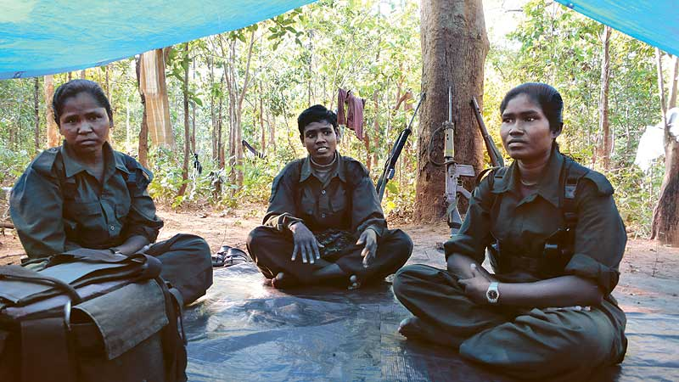
Bob-Cut Brigade: In Bastar, women with a bob-cut haircut can get you killed
Comrade Niti (Most Wanted) and Comrade Vinod lead us on a long walk to see the series of water-harvesting structures and irrigation ponds that have been built by the local Janatana Sarkar. Comrade Niti talks about the range of agricultural problems they have to deal with. Only 2 per cent of the land is irrigated. In Abujhmad, ploughing was unheard of until 10 years ago. In Gadchiroli on the other hand, hybrid seeds and chemical pesticides are edging their way in. “We need urgent help in the agriculture department,” Comrade Vinod says. “We need people who know about seeds, organic pesticides, permaculture. With a little help we could do a lot.”
Comrade Ramu is the farmer in charge of the Janatana Sarkar area. He proudly shows us around the fields, where they grow rice, brinjal, gongura, onions, kohlrabi. Then, with equal pride, he shows us a huge but bone-dry irrigation pond. What’s this? “This one doesn’t even have water during the rainy season. It’s dug in the wrong place,” he says, a smile wrapped around his face. “It’s not ours, it was dug by the Looti Sarkar (the government that loots).” There are two parallel systems of government here, Janatana Sarkar and Looti Sarkar.
I think of what Comrade Venu said to me: they want to crush us, not only because of the minerals, but because we are offering the world an alternative model.
It’s not an Alternative yet, this idea of Gram Swaraj with a Gun. There’s too much hunger, too much sickness here. But it has certainly created the possibilities for an alternative. Not for the whole world, not for Alaska, or New Delhi, nor even perhaps for the whole of Chhattisgarh, but for itself. For Dandakaranya. It’s the world’s best-kept secret. It has laid the foundations for an alternative to its own annihilation. It has defied history. Against the greatest odds it has forged a blueprint for its own survival. It needs help and imagination, it needs doctors, teachers, farmers.
It does not need war.
But if war is all it gets, it will fight back.
Over the next few days, I meet women who work with KAMS, various office-bearers of the Janatana Sarkars, members of the Dandakaranya Adivasi Kisan Mazdoor Sangathan (DAKMS), the families of people who had been killed, and just ordinary people trying to cope with life in these terrifying times.
I met three sisters—Sukhiari, Sukdai and Sukkali—not young, perhaps in their 40s, from Narayanpur district. They have been in KAMS for 12 years. The villagers depend on them to deal with the police. “The police come in groups of two to three hundred. They steal everything: jewellery, chickens, pigs, pots and pans, bows and arrows,” Sukkali says, “they won’t even leave a knife.” Her house in Innar has been burned twice, once by the Naga battalion and once by the CRPF. Sukhiari has been arrested and jailed in Jagdalpur for seven months. “Once they took away the whole village, saying the men were all Naxals.” Sukhiari followed with all the women and children. They surrounded the police station and refused to leave until the men were freed. “Whenever they take someone away,” Sukdai says, “you have to go immediately and snatch them back. Before they write any report. Once they write in their book, it becomes very difficult.”
Sukhiari, who as a child was abducted and forcibly married to an older man (she ran away and went to live with her sister), now organises mass rallies, speaks at meetings. The men depend on her for protection. I asked her what the party means to her. “Naxalvaad ka matlab hamara parivaar (Naxalvaad means our family). When we hear of an attack, it is like our family has been hurt,” Sukhiari says.
I asked her if she knew who Mao was. She smiled shyly, “He was a leader. We’re working for his vision.”
I met Comrade Somari Gawde. Twenty years old, and she has already served a two-year jail sentence in Jagdalpur. She was in Innar village on January 8, 2007, the day that 740 policemen laid a cordon around it because they had information that Comrade Niti was there. (She was, but she had left by the time they arrived.) But the village militia, of which Somari was a member, was still there. The police opened fire at dawn. They killed two boys, Suklal Gawde and Kachroo Gota. Then they caught three others, two boys, Dusri Salam and Ranai, and Somari. Dusri and Ranai were tied up and shot. Somari was beaten within an inch of her life. The police got a tractor with a trailer and loaded the dead bodies into it. Somari was made to sit with the dead bodies and taken to Narayanpur.
I met Chamri, mother of Comrade Dilip who was shot on July 6, 2009. She says that after they killed him, the police tied her son’s body to a pole, like an animal and carried it with them. (They need to produce bodies to get their cash rewards, before someone else muscles in on the kill.) Chamri ran behind them all the way to the police station. By the time they reached, the body did not have a scrap of clothing on it. On the way, Chamri says, they left the body by the roadside while they stopped at a dhaba to have tea and biscuits. (Which they did not pay for.) Picture this mother for a moment, following her son’s corpse through the forest, stopping at a distance to wait for his murderers to finish their tea. They did not let her have her son’s body back so she could give him a proper funeral. They only let her throw a fistful of earth in the pit in which they buried the others they had killed that day. Chamri says she wants revenge. Badla ku badla. Blood for blood.
I met the elected members of the Marskola Janatana Sarkar that administers six villages. They described a police raid: they come at night, 300, 400, sometimes 1,000 of them. They lay a cordon around a village and lie in wait. At dawn they catch the first people who go out to the fields and use them as human shields to enter the village, to show them where the booby-traps are. (‘Booby-traps’ has become a Gondi word. Everybody always smiles when they say it or hear it. The forest is full of booby-traps, real and fake. Even the PLGA needs to be guided past villages.) Once the police enter a village, they loot and steal and burn houses. They come with dogs. The dogs catch those who try and run. They chase chickens and pigs and the police kill them and take them away in sacks. SPOs come along with the police. They’re the ones who know where people hide their money and jewellery. They catch people and take them away. And extract money before they release them. They always carry some extra Naxal ‘dresses’ with them in case they find someone to kill. They get money for killing Naxals, so they manufacture some. Villagers are too frightened to stay at home.
Booby-traps has become a Gondi word. Everyone smiles when they hear it. They know other words too: Cordon and Search, Advance, Retreat.

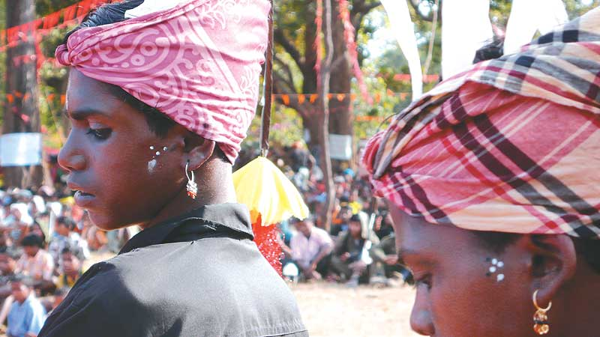
Dressed To The Nines: Adivasi boys in colourful traditional gear for Bhumkal day celebrations
In this tranquil-looking forest, life seems completely militarised now. People know words like Cordon and Search, Firing, Advance, Retreat, Down, Action! To harvest their crops, they need the PLGA to do a sentry patrol. Going to the market is a military operation. The markets are full of mukhbirs (informers) who the police have lured from their villages with money. I’m told there’s a mukhbir mohalla (informers’ colony) in Narayanpur where at least 4,000 mukhbirs stay. The men can’t go to market anymore. The women go, but they’re watched closely. If they buy even a little extra, the police accuse them of buying it for Naxals. Chemists have been instructed not to let people buy medicines except in very small quantities. Low-price rations from the Public Distribution System (PDS), sugar, rice, kerosene, are warehoused in or near police stations, making it impossible for most people to buy.
Article 2 of the United Nations Convention on the Prevention and Punishment of the Crime of Genocide defines it as:
Any of the following acts committed with intent to destroy, in whole or part, a national, ethnic, racial, or religious group, as such: killing members of the group; causing serious bodily or mental harm to members of the group; deliberately inflicting on the group conditions of life calculated to bring about its physical destruction in whole or part; imposing measures intended to prevent births within the group; [or] forcibly transferring children of the group to another group.
All the walking seems to have finally got to me. I’m tired. Kamla gets me a pot of hot water. I bathe behind a tree in the dark. But I can’t eat dinner and crawl into my bag to sleep. Comrade Raju announces that we have to move. This happens frequently, of course, but tonight it’s hard. We have been camped in an open meadow. We’d heard shelling in the distance. There are 104 of us. Once again, single file through the night. Crickets. The smell of something like lavender. It must have been past 11 when we arrived at the place where we will spend the night. An outcrop of rocks. Formation. Roll call. Someone switches on the radio. BBC says there’s been an attack on a camp of Eastern Frontier Rifles in Lalgarh, West Bengal. Sixty Maoists on motorcycles. Fourteen policemen killed. Ten missing. Weapons snatched. There’s a murmur of pleasure in the ranks. Maoist leader Kishenji is being interviewed. When will you stop this violence and come for talks? When Operation Green Hunt is called off. Any time. Tell Chidambaram we will talk. Next question: it’s dark now, you have laid landmines, reinforcements have been called in, will you attack them too? Kishenji: Yes, of course, otherwise people will beat me. There’s laughter in the ranks. Sukhdev the clarifier says, “They always say landmines. We don’t use landmines. We use IEDs.”
Another luxury suite in the thousand-star hotel. I’m feeling ill. It starts to rain. There’s a little giggling. Kamla throws a jhilli over me. What more do I need? Everyone else just rolls themselves into their jhillis.
By next morning the body count in Lalgarh has gone up to 21, 10 missing.
Comrade Raju is considerate this morning. We don’t move till evening.
One night, people are crowded like moths around a point of light. It’s Comrade Sukhdev’s tiny computer, powered by a solar panel, and they’re watching Mother India, the barrels of their rifles silhouetted against the sky. Kamla doesn’t seem interested. I ask her if she likes watching movies. “Nahin didi. Sirf ambush video (No didi. Only ambush videos).” Later, I ask Comrade Sukhdev about these ambush videos. Without batting an eyelid, he plays one for me.
It starts with shots of Dandakaranya, rivers, waterfalls, the close-up of a bare branch of a tree, a brainfever bird calling. Then suddenly a comrade is wiring up an IED, concealing it with dry leaves. A cavalcade of motorcycles is blown up. There are mutilated bodies and burning bikes. The weapons are being snatched. Three policemen, looking shell-shocked, have been tied up.
Who’s filming it? Who’s directing operations? Who’s reassuring the captured cops that they will be released if they surrender? (They were. I confirm that later.)
I know that gentle, reassuring voice. It’s Comrade Venu.
“It’s the Kudur ambush,” Comrade Sukhdev says.
He also has a video archive of burned villages, testimonies from eyewitnesses and relatives of the dead. On the singed wall of a burnt house, it says, ‘Nagaaa! Born to Kill!’ There’s footage of a little boy whose fingers were chopped off to inaugurate the Bastar chapter of Operation Green Hunt. (There’s even a TV interview with me. My study. My books. Strange.)
At night, on the radio, there’s news of another Naxal Attack. This one in Jamui, Bihar. It says 125 Maoists attacked a village and killed 10 people belonging to the Kora tribe in retaliation for giving police information that led to the death of six Maoists. Of course, we know that the media report may or may not be true. But, if it is, this one’s unforgivable. Comrade Raju and Sukhdev look distinctly uncomfortable.
The news that has been coming from Jharkhand and Bihar is disturbing. The gruesome beheading of the policeman Francis Induvar is still fresh in everyone’s mind. It’s a reminder of how easily the discipline of armed struggle can dissolve into lumpen acts of criminalised violence, or into ugly wars of identity between castes and communities and religious groups. By institutionalising injustice in the way that it does, the Indian State has turned this country into a tinderbox of massive unrest. The government is quite wrong if it thinks that by carrying out ‘targeted assassinations’ to render the CPI (Maoist) ‘headless’, it will end the violence. On the contrary, the violence will spread and intensify, and the government will have nobody to talk to.
On my last few days, we meander through the lush, beautiful Indravati valley. As we walk along a hillside, we see another line of people walking in the same direction, but on the other side of the river. I’m told they are on their way to an anti-dam meeting in Kudur village. They’re overground and unarmed. A local rally for the valley. I jump ship and join them.
The Bodhghat dam will submerge the entire area that we have been walking in for days. All that forest, all that history, all those stories. More than 100 villages. Is that the plan then? To drown people like rats, so that the integrated steel plant in Lohandiguda and the bauxite mine and aluminium refinery in the Keshkal ghats can have the river?
At the meeting, people who have come from miles away say the same thing we have all heard for years. We will drown, but we won’t move! They are thrilled that someone from Delhi is with them. I tell them Delhi is a cruel city that neither knows nor cares about them.
Only weeks before I came to Dandakaranya, I visited Gujarat. The Sardar Sarovar Dam has more or less reached its full height now. And almost every single thing the Narmada Bachao Andolan (NBA) predicted would happen has happened. People who were displaced have not been rehabilitated, but that goes without saying. The canals have not been built. There’s no money. So Narmada water is being diverted into the empty riverbed of the Sabarmati (which was dammed a long time ago.) Most of the water is being guzzled by cities and big industry. The downstream effects—saltwater ingress into an estuary with no river—are becoming impossible to mitigate.
The government has Koya Commandos, the CAF, CRPF, ITBP, CISF, Cobras, Scorpions. And a policy called wham: Winning Hearts and Minds.

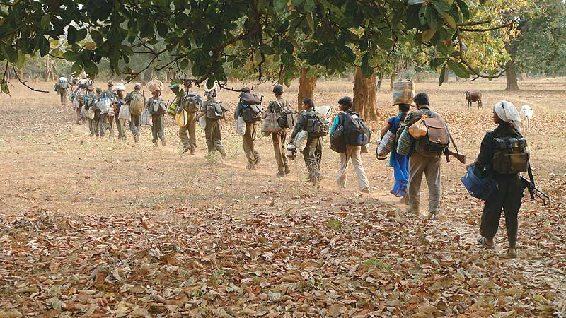
The Long March: Maoists on the move in Bastar, single file as always
There was a time when believing that Big Dams were the ‘temples of modern India’ was misguided, but perhaps understandable. But today, after all that has happened, and when we know all that we do, it has to be said that Big Dams are a crime against humanity.
The Bodhghat dam was shelved in 1984 after local people protested. Who will stop it now? Who will prevent the foundation stone from being laid? Who will stop the Indravati from being stolen? Someone must.
On the last night, we camped at the base of the steep hill we would climb in the morning, to emerge on the road from where a motorcycle would pick me up. The forest has changed even since I first entered it. The chiraunji, silk-cotton and mango trees have begun to flower.
The villagers from Kudur send a huge pot of freshly-caught fish to the camp. And a list for me, of 71 kinds of fruit, vegetables, pulses and insects they get from the forest and grow in their fields, along with the market price. It’s just a list. But it’s also a map of their world.
Jungle post arrives. Two biscuits for me. A poem and a pressed flower from Comrade Narmada. A lovely letter from Maase. (Who is she? Will I ever know?)
Comrade Sukhdev asks if he can download the music from my Ipod onto his computer. We listen to a recording of Iqbal Bano singing Faiz Ahmad Faiz’s Hum Dekhenge (We will Witness the Day) at the famous concert in Lahore at the height of the repression during the Zia-ul-Haq years.
Jab ahl-e-safa-Mardud-e-haram,
Masnad pe bithaiye jayenge
(When the heretics and the reviled will be seated on high)
Sab taaj uchhale jayenge
Sab takht giraye jayenge
(All crowns will be snatched away
All thrones toppled)
Hum dekhenge
Fifty thousand people in the audience in that Pakistan begin a defiant chant: Inqilab Zindabad! Inqilab Zindabad! All these years later, that chant reverberates around this forest. Strange, the alliances that get made.
The home minister’s been issuing veiled threats to those who “erroneously offer intellectual and material support to Maoists”. Does sharing music qualify?
At dawn, I say goodbye to Comrade Madhav and Joori, to young Mangtu and all the others. Comrade Chandu has gone to organise the bikes, and will come with me to the main road. Comrade Raju isn’t coming (the climb would be hell on his knees). Comrade Niti (Most Wanted), Comrade Sukhdev, Kamla and five others will take me up the hill. As we start walking, Niti and Sukhdev casually but simultaneously unclick the safety catches of their AKs. It’s the first time I’ve seen them do that. We’re approaching the ‘Border’. “Do you know what to do if we come under fire?” Sukhdev asks casually, as though it was the most natural thing in the world.
“Yes,” I said, “immediately declare an indefinite hunger strike.”
He sat down on a rock and laughed. We climbed for about an hour. Just below the road, we sat in a rocky alcove, completely concealed, like an ambush party, listening for the sound of the bikes. When it comes, the farewell must be quick. Lal Salaam Comrades.
When I looked back, they were still there. Waving. A little knot. People who live with their dreams, while the rest of the world lives with its nightmares. Every night I think of this journey. That night sky, those forest paths. I see Comrade Kamla’s heels in her scuffed chappals, lit by the light of my torch. I know she must be on the move. Marching, not just for herself, but to keep hope alive for us all.
Does the government think that by rendering CPI (Maoist) headless, it’ll end the violence? It’ll only spread and they’ll have no one to talk to.

http://www.outlookindia.com/printarticle.aspx?264738

